Extra Articles Instructions
Below are three extra articles. To use one of these extra articles in your newsletter:
PRINT-FORMAT NEWSLETTERS
- Copy the text of an article below. Then paste it into an existing frame on your newsletter (highlight the existing text, then paste over it). You may need to edit the content to fit the space after pasting it.
- Copy the image separately, then paste it into your newsletter and move it into place using your mouse. You may need to edit the margins of your text to fit around your image.
EMAIL-FORMAT NEWSLETTERS
To use an article in the Mailchimp newsletter, copy and paste the text into your email newsletter (using a Text Block) and reformat as needed. Save the image to your own computer and upload it to your Mailchimp account.

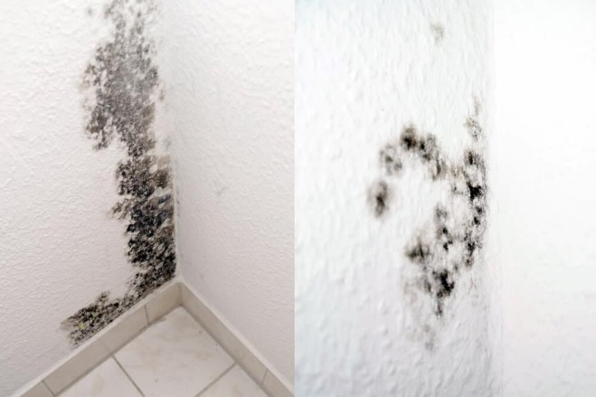
Eliminate Mold-Causing Moisture from the Bathroom
No matter where you live, high moisture in your bathroom makes mold difficult to control. Eliminate moisture by taking these steps:  First, after a bath or a shower, squeegee water off the shower walls. That eliminates at least three-fourths of the moisture that supports mold and mildew growth.  Second, run your fans during your shower and for a half hour after. | Third, seal grout lines annually with a standard grout sealer.  To get rid of current mold, scrub with detergent and water, then let the surface dry completely. Or use a solution of 10% bleach and 90% water (a stronger bleach solution will not give better results).  If the fans aren't clearing out most of the moisture after 10 minutes, your fans may not be moving | enough air. Ask an electrician for the right fan for your size of bathroom.  ~ See www.familyhandyman.com  for more household tips like this!  Call me if you need the name of a good electrician to help you buy and install the right fan!  555-333-2222
No matter where you live, high moisture in your bathroom makes mold difficult to control. Eliminate moisture by taking these steps:
- First, after a bath or a shower, squeegee water off the shower walls. That eliminates at least three-fourths of the moisture that supports mold and mildew growth.
- Second, run your fans during your shower and for a half hour after. Third, seal grout lines annually with a standard grout sealer.
To get rid of current mold, scrub with detergent and water, then let the surface dry completely. Or use a solution of 10% bleach and 90% water (a stronger bleach solution will not give better results).
If the fans aren't clearing out most of the moisture after 10 minutes, your fans may not be moving enough air. Ask an electrician for the right fan for your size of bathroom. Call me if you need the name of a good electrician to help you buy and install the right fan!

Simple Productivity Tips
If you tend to procrastinate, or drag your feet getting a task done, here's are two simple techniques that might help:
- Start using a timer. If you avoid tasks like cleaning the house, set the timer on your stove or phone for 15 minutes, then make an agreement with yourself to clean like mad for just those 15 minutes. The timer has a way of making the task more bearable because it has an end time.
- Use the Just 5 technique. Again, if you tend to avoid boring, difficult, or icky tasks, commit to doing just 5...just 5 push ups, just 5 dishes, just 5 minutes, just 5 clothes folded, etc. By committing to just 5, you get started on your task without feeling like you’re going to be stuck with it for a long time. Of course, once you get started on a task, it’s likely you’ll continue to do 5 more.

“Easily” Save $2,000/yr. with these Daily Habit Tricks
- Shop discount stores for groceries before going to your regular grocery store. Save 20% or more on your grocery bill without coupons!
- Get free stuff on Craigslist. People give away the most amazing things. Get a new dining room table, a trampoline, etc. for free.
- Buy yourself a cup of coffee. When you pour a cup in the morning instead of buying at Starbucks, put $2 into an envelope.
- Avoid online subscriptions you only use once in a while; also check your cell service to be sure you're not paying for more than you use.
- Avoid running to the store to buy food spontaneously. Many of us have lost the art of figuring out meals. Look through your pantry and try to put together meals from what you have.
- Replace TV cable with a digital antenna. These are no longer alien-looking apparatuses.
- Use a no-access jar for coins. Once upon a time, piggy banks had no hole in the bottom and you had to break them to get the money. Get a large pickle jar, punch a slit in the top for coins, then super-glue the lid on.

What Causes Summer & Winter?
It's (Probably) Not What You Think
During our cold winters, we can easily assume the earth is at the farthest point from the sun. When summer comes around, we must be at our closest to the sun. Right?
Not right. In July, the earth is swinging wide in its elliptical orbit, and is actually farthest from the sun, while in winter, it's actually closer to the sun. Why, then, is it so hot in the summer and cold in the winter?
The odd fact is that distance from the sun has almost nothing to do with summer heat or winter cold. The reason for seasons has to do with the tilt of Earth's axis which determines how long a part of the earth faces the sun, as well as the quantity of land vs. water mass, which acts to heat and cool the surface of the planet.

