Extra Articles Instructions
Below are three extra articles. To use one of these extra articles in your newsletter:
PRINT-FORMAT NEWSLETTERS
- Copy the text of an article below. Then paste it into an existing frame on your newsletter (highlight the existing text, then paste over it). You may need to edit the content to fit the space after pasting it.
- Copy the image separately, then paste it into your newsletter and move it into place using your mouse. You may need to edit the margins of your text to fit around your image.
EMAIL-FORMAT NEWSLETTERS
To use an article in the Mailchimp newsletter, copy and paste the text into your email newsletter (using a Text Block) and reformat as needed. Save the image to your own computer and upload it to your Mailchimp account.

What Are the “Moring Star” and “Evening Star?”
You might have heard these referenced, often in literature, the Bible, and in weather reports. But what are they?
First off, it’s usually not a star at all. Most references are to Venus, which appears like a star close to the sun. Because of its orbit, Venus sometimes appears to be leading the sun, and sometimes following. When Venus is trailing the sun, it appears in the sky moments after the sun goes down. This is when it is called an evening star. When it’s leading the sun, it appears to rise near dawn, just before the sun comes up. That’s when it’s called a morning star. It isn’t always Venus, as the other planets also wander around and may at times be visible morning and evening. But Venus is the most common.

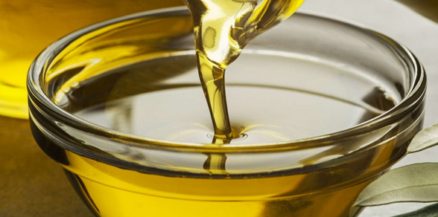
Not All Cooking Oils Cook the Same
All oils are 100% fat, meaning that they all have 9 calories per gram. Oils that claim to be "light" are making a statement about their flavor, not their calories. However, what's in those calories still makes some oils healthier than others. Healthy oils include olive, sunflower, canola, grape seed, safflower, walnut, flaxseed and peanut.
Not all of these oils are good for frying, though. In fact, if you heat certain oils past a certain temperature, they can become unhealthy. For high-temperature cooking, such as deep frying, stick to canola, sunflower or peanut oil.

Pros and Cons of Buying a Tenant-Occupied Rental Property
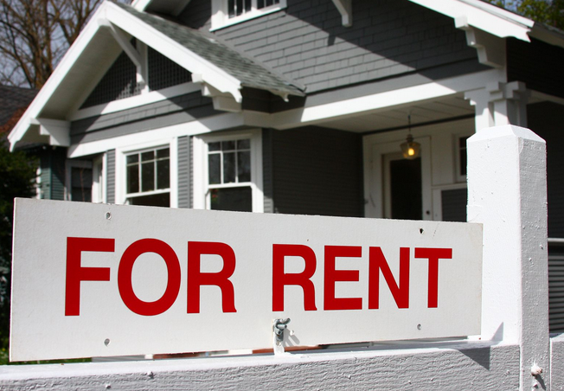
So you’re thinking about buying a rental property, including tenants. Sounds good because you don’t have to find a tenant, right? Maybe. Here are some pros and cons:
Cons:
- There are some legal risks. If the property isn’t in compliance, and the tenant complains, it’s the responsibility of the new owner to bring the property into compliance. At the same time, inspections are difficult to do in a tenant-occupied property, meaning there’s greater risk of possible problems.
- Removing bad tenants can be complicated. Even though the previous owner said the tenant was good, that might not be the actual case. Once you own the property, that tenant becomes your problem.
- If rents are low, you may have a hard time raising them, especially if you want to keep the current tenants. Check the current leases to see what you can and can’t do.
Pros:
- You get immediate rental income. You’re not paying for a vacant property. The rent may be enough to cover your expenses, or not. But as a smart buyer, you probably have a plan to cover costs and raise those rents in time.
- You don’t have to make an extra investment to create a rental space or find a tenant.
Thinking of buying a tenant-occupied rental property? Here’s a short checklist of what you should do before buying a property with tenants.

