
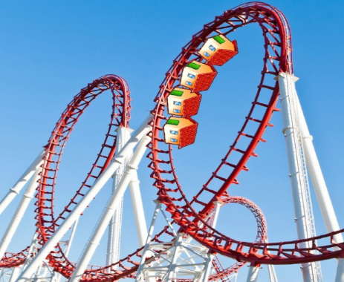
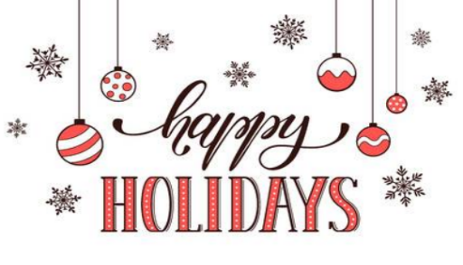
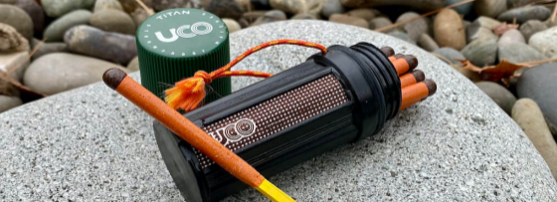

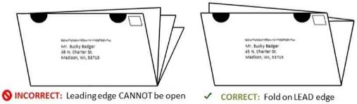
Upper Panel Instructions
1. You can use this area for mailing labels. See the image for the correct way to fold and tab your newsletters on Tabloid paper. Seal all the edges using tabs. (Printing Tutorial – Control + Click to view.)
2. You can use this area for content. If you don’t plan to mail the newsletters as self-mailers, then you can add your own content to this area instead of labels. First delete the back page title and return address.
To delete the yellow instruction boxes, click on
an edge of the yellow box, then click DELETE on your keyboard.

Looking for stocking stuffers & friend gifts?
Here are some Ideas…
I'm always looking for unique and useful gifts that someone can use around the house. I am a Realtor, after all. This year I'm doing these Google searches:
DIY tools for stocking stuffers. Find odd little tools that someone wouldn’t buy themselves, but that’s what makes them cool, like a magnet on a stick for lost screws.
Stocking stuffers for foodies. From Kale razors to pie weights, you’ll find something they don’t already have.
Stocking stuffers for RV campers. From waterproof matches to clip-on wine glass holders, there’s something for every type of camper.
I’m wishing you a wonderful season of holiday traditions. I hope you and your loved ones are able to share time together, which is the most precious gift of all. I'll see you in the New Year, if not before!
~Your Name
FRONT PORCH NEWS
Your Name | 555-333-2222 | email@emailaddress.com | Your Website

Let’s start with something just for fun...
How to run a business like Santa Claus
- Be aware. Know when opportunity is sleeping. Know when it’s awake. Act accordingly.
- Be organized. Have a list. Check it twice.
- Be psychic about the market: Give your customers exactly what they've always wanted.
- Don't be afraid of hiring those who are different: Rudolph. Red Nosed. Reindeer. Enough said.
- Have a clear, singular mission, like "Spend all year making toys, then deliver them in 24 hours on Christmas Eve."
- Know your customer...who's naughty and nice for your business.
- Be a wise and jolly leader.
~Inspired by "Santa Business Model" by speaker Jim Carroll

Make your real estate plans for 2023
Call for a consultation about buying or selling. It’s not too soon!

And now to get serious…
How long will
this take?
I'm sure you know that real estate is taking a dip right now. When that happens, it's hard to remember that real estate is like a roller coaster: what goes down always comes back up. Still, the question on everyone's mind is,
How long will it take? History might hold an answer...
In 1982, fixed rate mortgage interest peaked around 18% (can you imagine?). Over the next 11 years, rates began a slow decline until 1993, when rates reached 7.5%, similar to today. At that point, rates
Continued on page 4, bottom.
Your Name
Your Company
Address
Address
Real Estate License#

FRONT PORCH NEWS
This newsletter is for entertainment purposes only. Credit is given to the authors of articles that are reprinted when the original author is known. This information is solely for entertainment, and should not be substituted for medical, legal, financial or tax advice. Do not hold us responsible for actions you take without proper medical, financial, legal or tax advice. This is not intended as a solicitation of listed property.

Continued from page 1: How long will this take?
essentially froze for the next 16 years. It wasn't until 2009 that rates dropped to 5% and below. If history repeats itself, 1) today's rates could go much higher, and 2) the decline back to lower rates could take as long as 27 years (the period from 1982 to 2009).
Will this happen? Will rates climb and climb? And will it take 27 years for them to fall again? Your guess is as good as mine. But if I look into my foggy crystal ball, I think rates are likely to stabilize for a while between 6% and 8% (I'm hedging my bets). As inflation gets under control and the world stage calms down, we may even see rates dip below 6% again. But I seriously doubt they’ll get much lower in the next few years.
My sense is that now is a good time to sell a home to get maximum profit. Values are unlikely to rise much more and may fall if rates climb again. Contact me for a no-obligation listing consultation.
Your Name
555-333-2222
email@emailaddress.com


Personalize Your Newsletter
Change all RED TEXT (and red circled text) throughout before making other changes.

To Insert Your Picture/Logo
Click once on the image to activate it. LEFT click, NOT right click!
Go to the INSERT tab on the edit ribbon at the top of the screen. Chose INSERT >> Pictures
Move and resize your image using your mouse. If the picture jumps to a new page, then CROP the image. Find the Crop function on the Picture Format menu, after clicking on the image.



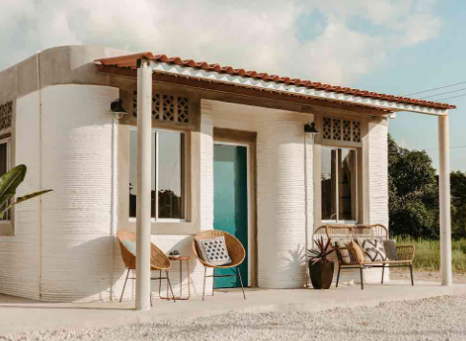


Free Report
Should you Sell First or Buy First?
If you make one choice—sell first, then buy—you stand to lose one way. But if you make the other choice—buy first, then sell—you stand to lose another way. Which risk should you take?
Use your QR app to read now, or text me for a copy.

Quiz Contest - Win a FREE Coffee Card
Email me the answer to the question on page 2. Put the word QUIZ in the subject line. email@emailaddress.com
- Last month's Q&A: What word is hidden in the stereogram image?

Congratulations to last month’s winner!

I appreciate you!
I’m grateful to all of you that you have been part of business. Special thanks this month to…
Name 1
Name 2
Name 3
Please refer your friends for real estate help. I’ll take great care of them!
December 2022 Your Name | 555-333-2222

Want to have your next home 3d printed?
Here's what that would cost...
Using normal construction, the cost to build an average sized 3-bedroom house runs US$250K-320K / CA$315K-400K (not including land).
Building the same home with 3D printing technology would cost 20 to 40 percent less. So that same 3-bedroom house would cost US$140K-240K / CA$175K-300K to build with 3D printing.
You’ll also need to have land suitably flat and accessible for the printing equipment.

What do you regret about buying a home?
Here are 5 of the responses from a recent survey of buyers who were asked what they regret about buying.
1. "I wish I had put more effort into finding a good Realtor instead of assuming it didn't matter. We lost thousands because of an inexperienced agent." Don't let this happen to you! Call me (or refer me to your friends) for experienced real estate representation.
2. "I regret buying the right size home for the 'now' rather than the future ... I’d say if you want two bedrooms, look for properties with three." This won't be the case for everyone, and many people say the opposite--that they wish they'd bought smaller. My advice is to look at how you'll live in that house for the next 5-7 years.
3. "I wish we would have set aside more money and had gotten individual inspections by professionals on top of the overall inspection." I've said it before and will again...a home inspection is only the first inspection. Its purpose is to show you what specialist inspections you should be getting.
4. "Get as much insurance as you can reasonably afford, not just the minimum." Again, this depends on your situation, but certainly if you're in a danger zone, insure yourself against the likeliest issues.
5. "I regret not using a local lender. I went with a big online mortgage company. They didn't know about a specialty program that could have saved me thousands. They were a one-size-fits all company." Local lenders tend to have a lot of knowledge, plus you can talk to them in person. Text or call me for referrals to local lenders. ${Phone}
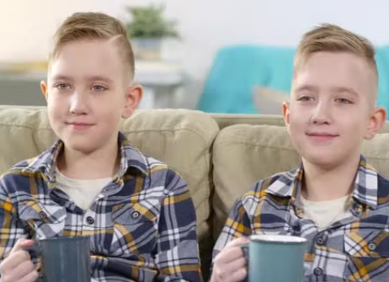


There are three boxes of ornaments. In each box there is either a set of big ornaments, small ornaments or big and small ornaments mixed. The boxes are labelled BIG, SMALL, and MIXED but each box is labelled incorrectly. What is the least number of boxes you can open to know which ornaments are in which box?
December Quiz Question

Lose Weight by Eating Only When the Sun's Up
The connection between eating time, sleep, and obesity is well-known but poorly understood. Research clearly shows a connection between "overnutrition" and disruptions in circadian rhythms and growth in fat tissue. It's just not been clear, until now, what causes that connection.
Now, for the first time, research has found that "energy release" may be the molecular mechanism through which our internal mechanisms control energy balance.
Essentially, our bodies are like fine-tuned clocks. Humans are designed to eat and burn calories during daylight, and conserve at night. When we disrupt that balance by eating late in the evening, we're telling our bodies to conserve the food we just consumed.
In this research, nocturnal mice were fed a high-fat diet either exclusively during their inactive (light) period or during their active (dark) period. Within a week, mice fed during light hours (what would be the equivalent of our human night hours) gained more weight compared to those fed in the dark.
Clearly this has implications for timed eating...eating only during set hours of the day during daylight hours.

Story Time

A Holiday Lesson in Integrity
A father took his twin sons to a Santa-themed event at his local shopping center. Santa would be there, and the kids could pet a live reindeer. When he arrived at the place, he was surprised to see an entrance fee.
• General admission: (ages 10 and up) $10
• Children under 10: $5
Thinking this was outrageous, he wanted to leave, but he had made a promise to the kids. Sighing, he went to the window and asked for three general admission tickets.
The ticket taker asked the dad, “How old are your boys?”
“They're both 10 years old,” he said, smiling at his boys. “They're twins.”
The ticket taker leaned forward. “You know,” he said conspiratorially, “you could have said they were 9 years old, and I never would have known.”
“Yeah,” said the father back, “but they would have.”

