Extra Articles Instructions
Below are three extra articles. To use one of these extra articles in your newsletter:
PRINT-FORMAT NEWSLETTERS
- Copy the text of an article below. Then paste it into an existing frame on your newsletter (highlight the existing text, then paste over it). You may need to edit the content to fit the space after pasting it.
- Copy the image separately, then paste it into your newsletter and move it into place using your mouse. You may need to edit the margins of your text to fit around your image.
EMAIL-FORMAT NEWSLETTERS
To use an article in the Mailchimp newsletter, copy and paste the text into your email newsletter (using a Text Block) and reformat as needed. Save the image to your own computer and upload it to your Mailchimp account.

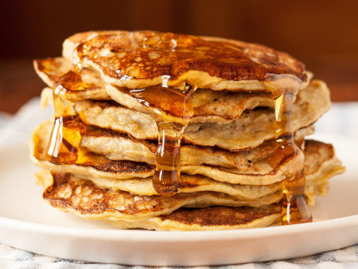
These pancakes are bananas
Really. They're bananas and eggs. That's all. The eggs turn the bananas into pancakes. That’s it. Whisked together in a good skillet, you've got the perfect non-gluten, non-dairy treat...and even if you're not gluten or dairy intolerant, you'll love them. At least you will if you love bananas. The recipe? 1 ripe banana. 2 large eggs, lightly beaten. Mix the two. Fry on a griddle or skillet with a dabble of oil or butter (optional). Serve with syrup, powdered sugar, fruit, etc.

Fight aging with 3-way conditioning
As we get older, our muscles and ligaments get tougher, less flexible. That leads to pain in our joints and muscles when we do simple things that never bothered us before. The best way to remain nimble in old age is continuous proper conditioning. Proper conditioning can be thought of as a three-legged stool. The first leg is flexibility, the second is cardio endurance, and the third is strength. As you get older, you’ll need to give equal time to all three.

What Are the “Moring Star” and “Evening Star?”
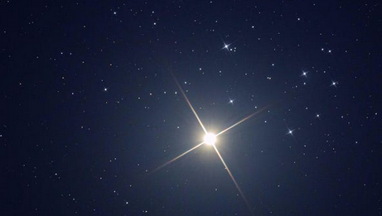
You might have heard these referenced in literature, the Bible, and in weather reports. But what are they?
First off, it’s usually not a star at all. Most references are to Venus, which appears like a star close to the sun. Because of its orbit, Venus sometimes appears to be leading the sun, and sometimes following. When Venus is trailing the sun, it appears in the sky moments after the sun goes down. This is when it is called an evening star. When it’s leading the sun, it appears to rise near dawn, just before the sun comes up. That’s when it’s called a morning star. It isn’t always Venus, as the other planets also wander around and may at times be visible morning and evening. But Venus is the most common.

