The Psychology behind home pricing strategies

In real estate, the asking price is often as much about psychology as it is about reality. For example, take the strategy of pricing your home below market value...
"I priced my home $9,000 under the market," says Rebecca Ricci. "It was a gamble, but my home was unique. People either love it or hate it. Also the market was flat. Houses were starting to set on the market a little longer."
The lower price strategy is designed to create interest, which creates offers. And it worked in Rebecca's case. She received seven offers and sold her home for $1,000 over market value, plus she was able to negotiate lower repairs.
Would she have sold just as quickly if she had priced right at market value? No one knows for sure, but given the uniqueness of her home, she benefited from the high energy that the lower price generated.
When should you use a low-ball pricing strategy to sell your home? Or for that matter, any particular pricing strategy?
Here are three pricing strategies to consider:

The Low-Ball Pricing Strategy
The purpose of the low-ball pricing strategy is only to attract a larger number of buyers. It doesn't necessarily attract offers or even higher prices.
Sometimes a home can be low-ball priced in a warm market. That will create a bidding frenzy that ups the offers considerably over market value. However, you probably wouldn’t benefit from using this strategy in a cool or cold market, when there are a lot of homes for sale and prices are falling. Even in a warm market, before taking that risk, you must know the market well and understand your product (your home) in comparison to others.
The main reasons to do the low-ball pricing strategy are:
- Your home is not in peak condition, and you're hoping to negotiate fewer repairs in exchange for the lower price. If you can create a bidding war, there's a better chance of getting your way with repair negotiations.
- Your home is in a very desirable location and is smaller than surrounding homes. The low price will attract buyers, the great location will make them flock to it, and the competition can generate offers.
- Your home has unusual features that you feel must be viewed in person. The lower price gets them in the door. The more buyers who see it, the more excited they'll be and the more they'll want to buy.
Remember, just because you’ve priced it low, you are not forced to accept an offer. If you only get one offer and it’s at your low price, you are not obligated to accept. You can discuss a higher price with the buyer, or you can withdraw your home from the market and cancel the sale. Then rethink your strategy.

Price AT Market Value
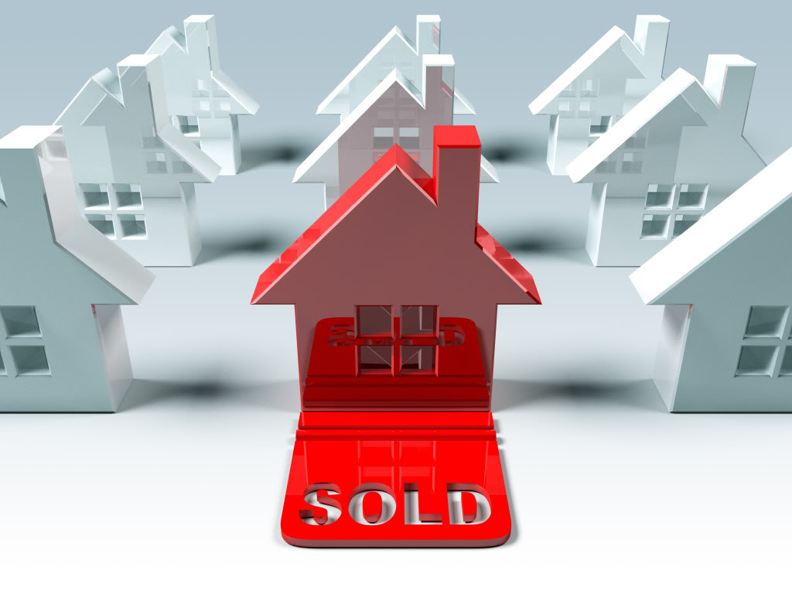Another negotiating tactic applied in pricing a home is to price it at market value. What? That's a pricing strategy?
Sure it is. Many home sellers don't want to price at market value.
First of all, there's sometimes a suspicion that the price their agent is giving them isn't really market value. Or that the agent doesn't have all the facts. Or that the market is hotter in the seller's area than the agent thinks it is. Ideally, a home seller would discuss these perceptions and ask for data points to help in making a decision.
Second, many sellers believe that buyers want to low-ball them. They believe that they need to price higher so they have room to negotiate with the buyers.
That makes sense. But it isn't necessarily accurate. Sellers have a lot of control. When they price fairly, they get offers. When they price too high, they significantly reduce the number of offers they get.
But with offers in hand, sellers can then evaluate and decide what to do with each offer.
For instance, they can reject, counter, or alter the terms, or even "throw in" extras. Imagine this:
- The seller is asking $500,000, which is fair market value.
- A buyer offers $490,000, which is a typical strategy.
- The seller counters the offer and puts the price back at the original $500,000, but offers to throw in the hot tub (which he really didn't want to move anyway).
- Now, the buyer knows the hot tub isn't worth $10,000. But he was just fishing anyhow, and now he gets a hot tub (how cool is that?) and a house for fair market value.

Over-Pricing Your Home
Does it ever make sense to over-price your house?
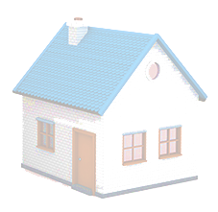
It only makes sense if your home has some special feature, usually intrinsic to the location in COMPARISON to other homes in the area. For instance:
- Your home is a half block from a
popular hiking trail, and homes
never come up for sale on your
street.
- Or for some reason, the builder made
all the bedrooms in your home five square meters larger than in other homes nearby. Not a half meter...five meters.
- Or through a trick of the land, your home has a killer view that none of the others have. Not just a slightly better view…an amazing view worth paying extra for. And by the way, it still has to be in a nice location. Having a killer view would not add much value if the home is on a main street. However, in that case, the killer view might offset the bad location and help the home sell for fair market value.
In other words, the advantage of the feature must be significant and intrinsic. Having cherry wood kitchen cabinets would not be an intrinsic feature. Having an open kitchen that overlooks a killer view might have intrinsic value, if it's the only one like that in the area.

What Is Your Home Really Worth?
With so many variables in play, how do you know what the actual market value is for your property?
Here's the process your appraiser and a good listing agent will go through to determine value:
- Gather comps (comparable sold properties) within 0.5-1-mile radius of the property being sold.
- Select sold comps for the past three months that are within the size range, plus or minus a tiny amount, within five years in age, and with a similar floor plan to the subject property. That's easy to do in a planned community. Much harder for a custom area or home.
- Add and subtract features, giving points for intrinsic value and condition, and detracting points for such things as a poor location, bad condition, obsolete floorplan or features, etc.
- Note the Days-on-the-Market, since quick sales that close quickly demonstrate that the property was priced correctly for the current marketplace (what buyers are willing to pay right at this moment).

The best strategy for pricing your home is to ask me for a full market evaluation. Call today for an appointment that fits your schedule.

