Extra Articles Instructions
Below are three extra articles. To use one of these extra articles in your newsletter:
PRINT-FORMAT NEWSLETTERS
- Copy the text of an article below. Then paste it into an existing frame on your newsletter (highlight the existing text, then paste over it). You may need to edit the content to fit the space after pasting it.
- Copy the image separately, then paste it into your newsletter and move it into place using your mouse. You may need to edit the margins of your text to fit around your image.
EMAIL-FORMAT NEWSLETTERS
To use an article in the Mailchimp newsletter, copy and paste the text into your email newsletter (using a Text Block) and reformat as needed. Save the image to your own computer and upload it to your Mailchimp account.

Breathe life back into your kitchen
The kitchen is one of the most used rooms in the house. It's where our scattered families gather (or at least run into each other now and then), but it can also be outdated or unappealing with lackluster paint or tired cabinetry or lighting from 15 years ago. If you'd like to breathe new life into that well-used room, you don't need to break down the walls or strip cabinets. Here are 8 easy ways to spruce things up.
- Change your cabinet and drawer pulls. Buy a size that fits existing holes so you don't need to drill new holes.
- Add rope or stick-on lighting under or over your cabinets.
- Add some kitchen-relevant art, such as a café painting or kitschy spoon and fork mosaics.
- Choose 3 complimentary colors and update everything you can to match, like paint, towels, rugs, small appliances, canisters, and curtains.
- Paint an unused wall/surface with chalkboard paint. Use colorful chalk to write a quote each day or week.
- Add a new backsplash using stick-on tile.
- Replace the faucet with something ultra-modern.
- Replace boring lighting with something interesting or unusual.

Can I Quitclaim My House to Someone Else Whenever I Want to?
If you own your house yourself (even if there's a mortgage), you have a right to file a quitclaim deed and give it to someone else. Quitclaim means to hand the house over to someone else, and "quit" any claims you have to it. No money needs to be exchanged.
However, if you have a mortgage on the property, the new owner would have legal ownership of the property, but you would still be liable for the mortgage. To be fully released from the mortgage, you’d have to get the new owner to take out a new loan and pay off the existing mortgage, just as if it were being sold on the open market. Also, filing a quitclaim deed on a property that has an existing mortgage might trigger the mortgage company to accelerate and demand the loan be paid in full, so the home would require a new loan in any case. A mortgage is a lien against the property in the owner’s name, so any change of ownership would automatically notify the bank that holds the mortgage.

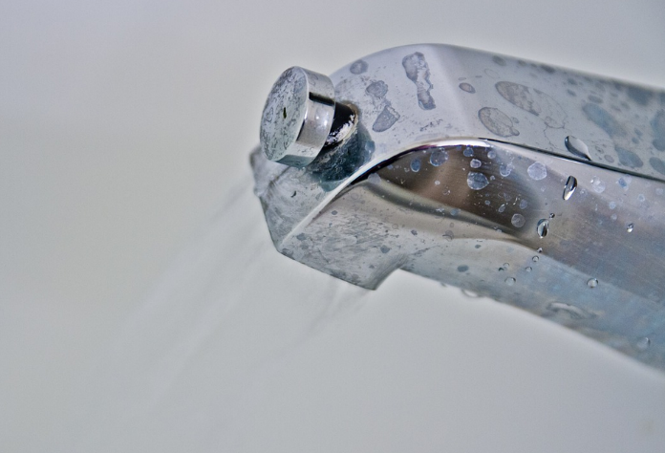
Replacing your own bathtub faucet might be easy
Want to replace (or need to replace) your bathtub faucet? It may be WAY easier than you think to do it yourself. There are two main types of tub spouts: threaded and slip-on. To determine which style you have, look underneath the fixture where the surrounding wall meets the tub spout. If you see a screw, your fixture is a slip-on spout with set screw. A screw indicates the faucet slips onto a spout and then the tiny screw applies pressure to hold it in place. If there’s no screw, it’s a threaded spout. A threaded spout screws on and off a pipe that comes directly out of the wall (turn the entire spout). Once you know which type of faucet you have, you can Google instructions for replacement.

