Do Open Houses work…Or are they a waste of time?
There are definite reasons to hold open houses, and reasons to not. Read more to evaluate your best course of action!

When you hire a real estate agent to sell your home, one of the first things they'll suggest is hosting an open house so that potential buyers can casually check out your property on a weekend afternoon. But while open houses are promoted by agents as a great way of finding a buyer, a US study by the National Association of Realtors (NAR) found that the success rate of open houses is a mere 2% to 4%. Similar studies in other countries have mirrored these results.
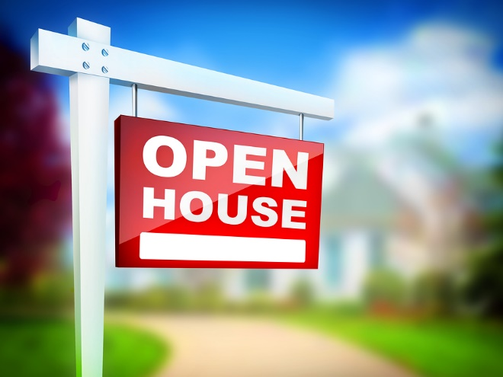
That means out of 100 open houses, only 2 to 4 homes are purchased by buyers who came through that home’s open house.
So, with that sobering data, why do real estate agents still promote open houses as a listing and selling tool? Let’s look at a few arguments for and against open houses.

Reasons not to hold an Open House
There are many people—agents and consumers—who argue against open houses. Some sellers just don't like the idea of random people and neighborhood "lookie-loos" traipsing through their house. Some are concerned about theft.
Some agents are concerned about their own safety when holding an open house, especially in out-of-the-way locations. Some agents consider it a waste of their time, based on the low potential results...they'd rather be managing other aspects of their business (or golfing) during that time.
One of the main arguments used by sellers and the general public against open houses is that agents only use them to find buyers that they’ll take away to other houses.
But this is not necessarily a bad thing. Real estate is a community product and selling it is a community event. Buyers may meet an agent at your open house, then go buy another house…but another buyer somewhere is meeting another agent at another open house, and that agent is bringing the buyer to your house.
Open houses bring buyers out. By having an open house, you’re contributing to the overall health of the industry. As many as 45% of buyers use open houses to research the market. Many go to open houses, then discover they like the neighborhood and look for other homes in that area with their agent. Your house might be one of their “test” houses, or it may be one that they decide to buy because of another person’s open house in your neighborhood. It's a network.

Valid Reasons you should Hold an open house
In addition to being part of a network of buyers and home sellers, consider these five additional reasons to hold an open house:

Get “shoppers” out of the way
A lot of buyers will want to see your house as soon as it's listed. You can become overwhelmed by the repeated appointment requests. Showing your home is disruptive and quickly becomes annoying. Having to keep the place clean and be ready to vacate on a moment’s notice may seem fine for the first few days, but you’ll lose patience with the process if it drags on. In today’s market, homes are still selling quickly, but you may find yourself showing it for a few weeks before the best offer is submitted.
By holding an open house, your agent can get a ton of those early "shoppers" through your house at one time, rather than bothering you with appointment after appointment. Most of those buyers will eliminate your house as an option during the open house. Some will want to view it again. And a very small percentage may want to make an offer. But the biggest reason to hold the initial open house is to get the lookie-loos and initial round of buyers out of the way. They're just shopping, not buying.

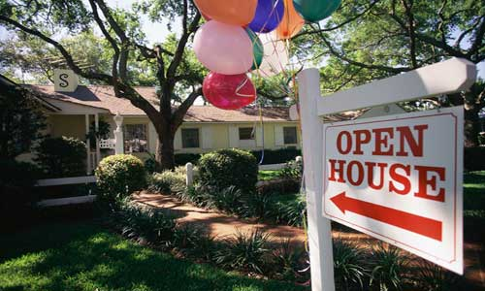
You may want to ask your agent to hold the house open on both Saturday and Sunday of that first weekend. By doing a "new listing" open house, you won’t eliminate all appointments (some people can't come during the open house time), but a large percentage will come during the open, and that means those people won't be bothering you during the week to set appointments.

Create an "auction effect"
There is a principle in psychology called scarcity – it's the desire that's in all of us to want to get something valuable before someone else does. For instance, when more than one person wants your house, it generates a bidding war. Bidding wars often result in the home selling for more than the asking price – and the buyers still feel great about it because they won. It’s a win-win for the seller and successful buyer.
Situations like this are called an auction effect. An open house on a new listing can add to the auction effect by focusing a lot of buyers on the house at one time, creating a sense of competition. It happens all the time!

Draw in larger groups of buyers
While a single open house might not get a lot of foot traffic, a community or neighborhood-wide open house can draw in more buyers for all the open houses, yours included. In this situation, agents agree to hold open houses on listings that are near one another.

4. Get useful feedback
A new listing open house is a great time to get feedback on the property. Information is valuable. Your agent should be asking things like, "How does this house compare to others you've been seeing?" "What do you like about the home?" "What would prevent you from making an offer?" Your agent can use different techniques to gather feedback, such as surveys, direct conversation, feedback forms, etc.
It's important to take feedback to heart. If you keep hearing the same input over and over again, then those things are real and may be preventing your home from selling quickly or for top dollar. It doesn't hurt to listen and then have an open-minded discussion with your agent about how to remedy those issues.
Contrary to popular opinion, most agents are not going to tell you to drop your price or landscape your front yard just so they can sell your house faster.
They’ll only tell you those things if they think your price or landscaping, etc. are interfering with the sale of your home.


Showcase a unique property
In some cases, a house is so unique that it requires an open house to sell it.
For example, art professor Maria Acevedo insisted on open houses to showcase their California home, because "It had a unique sensibility, with spacious rooms and a large amount of built-in furniture that was crafted by hand. It felt solid,” according to the listing agent. Those things didn’t show up in the listing’s online photos. The house literally felt different once people went inside.
Sometimes you must get people into a house in order to get them to fall in love with it.

Final Word
When you hire me to represent you in the sale of your home, we’ll discuss the pros and the cons to having open houses as part of your marketing plan.
I’ll let you know what’s happening in the market—whether open houses are effective right now or not—and whether your house would benefit from open houses, given its style, price, and location.

call to set a listing appointment well before your desired move date (4-6 months is ideal, but we can work with tighter timeframes, too)

That gives us plenty of time to plan your home’s marketing and moving details.

