how to buy land
& build a house
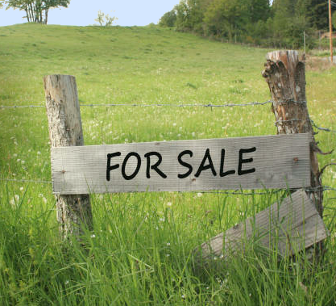
Is it cheaper to build or buy? What are the steps to building, if that's the goal?
Is it cheaper to build or buy, and what are the steps to building, if that's the goal?
In 2023, the average cost to BUILD a home in the US is around US$284,723. In Canada, the cost is around CA$385,321.
The average cost to BUY an existing home in the US is around US$400,000. In Canada, the cost is CA$662,000.
It seems like building would be cheaper, right? If we are only talking about erecting a structure, then it is cheaper. However, the building costs cited don't include the cost of buying the land or developing the land.
Let's dig into the details: How to buy land and build a house in 4 steps.

Looking for Land
As mentioned above, the land development costs are separate from average building costs. That's because there's no way to estimate an average. Some land is miles from the nearest utilities. Other land is in a subdivision with utilities already stubbed in a few meters from the property. Some land is rocky and hard to dig. Other land is flat and easy.
So, as you're looking for land, or considering the buildability of the land, particularly the following:
UTILITIES. Research the location of nearby utilities, the availability of tapping into those utilities, and the zoning for what you want to build. You may need to use propane, dig a well, install solar, or put in a septic tank.
LAND QUALITY: Can the land be developed easily, or will it require literally moving mountains? Are there nearby waterways to protect? Do you have access to bring in development equipment? Are there future plans for nearby land that could affect your property value or enjoyment?
To keep costs down, look for lots in existing or planned developments, where a developer has already invested in stubbing in utilities, has paved some roads, and where the land is attached to sewer or large enough and appropriate for a septic system, if necessary.

Financing Your Land Purchase
Financing a land purchase isn’t as easy as applying for a traditional mortgage. Most people buy land with cash.
If you don't have cash to buy the land, you might be able to work out a deal with the current land owner to buy it from them on a "land contract" (sometimes called owner-financing). You may be able to pay the loan off once construction is complete and you refinance. Or you may want to continue with the land contract if the terms are highly favorable.
If you're buying a lot inside a planned development, chances are the developer will help finance the purchase of the land along with building the new house for you. This is called "improved land," and can be more cost-effective.
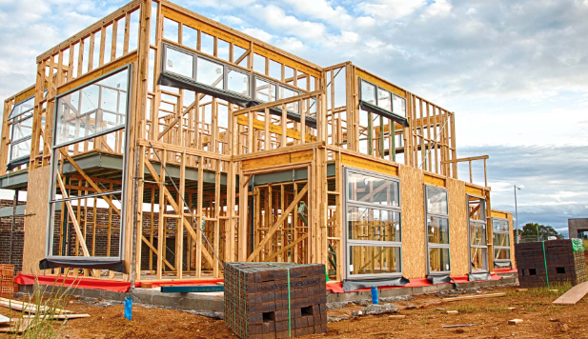

Financing Construction
You’ll also need to fund the construction of your home. Unless you’re paying in cash or have some other funding, you’ll need some form of construction loan. Construction loans come in two types: stand-alone loans and construction-to-permanent loans.
Stand-alone loans only fund the building of the house and usually must be paid off once construction is done (ideal if you're building on spec to sell right away). You may be able to get a new mortgage on your finished home to pay off the construction loan.
Construction-to-permanent loans can be simpler. It’s one loan with one lender that fund the construction, then it converts to a monthly mortgage once the house is built.
You'll want to discuss these options with your lender. Let me know if you need a referral to a local lender.

Preparing to Build
Once you’ve purchased the land, you’ll need to prepare to build. This means hiring an architect and contractor. They will help you design according to the property limitations and your personal design preferences. Then they'll help you apply for the correct building permits.
Expect to pay the architect between 5% and 20% of the cost of the build. If the home is in a development, the builder or developer may be able to provide architectural plans at low or no cost.
If you hire an architect and contractor who are familiar with the area, they will know the local building codes and requirements for your permits.

Do You Need to Hire a Real Estate Agent to Buy Land?
It’s not required, but it’s probably a good idea. A real estate agent or land broker experienced in land deals in the area you’re interested in will be able to guide you through the purchase.
Having an experienced agent can be invaluable for advice and guidance. They’ll be able to find the right property for you and help you negotiate the sale. On top of that, they may be able to recommend a good lender or reputable area contractors to build your home.
Contact me for information about building in our area.

