Extra Articles Instructions
Below are three extra articles. To use one of these extra articles in your newsletter:
PRINT-FORMAT NEWSLETTERS
- Copy the text of an article below. Then paste it into an existing frame on your newsletter (highlight the existing text, then paste over it). You may need to edit the content to fit the space after pasting it.
- Copy the image separately, then paste it into your newsletter and move it into place using your mouse. You may need to edit the margins of your text to fit around your image.
EMAIL-FORMAT NEWSLETTERS
To use an article in the Mailchimp newsletter, copy and paste the text into your email newsletter (using a Text Block) and reformat as needed. Save the image to your own computer and upload it to your Mailchimp account.

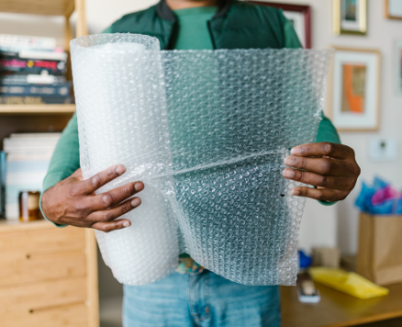
Bubble Wrap Started Life as Wallpaper
My latest shipment from Amazon was wrapped in bubble wrap, which I don’t see much anymore. As I popped a few bubbles, I wondered who invented it. It started in 1957, when engineers Alfred Fielding and Marc Chavannes laminated two plastic sheets together with air bubbles between and tried selling it as decorative wall covering. When no one bought it, they tried using it as greenhouse insulation. When that didn’t fly either, they began using it as packing material, leading to BUBBLE WRAP®. Yes, bubble wrap is a brand name. It was the first product of the Sealed Air Corporation, founded by Fielding and Chavannes in 1960. Today Sealed Air still plays a big role in safe packaging.


You'll Need More Retirement $$$ Than You Think
Every working adult has a responsibility to figure out how to support themselves in retirement. That means having your debts mostly paid and a source of income to support you when no longer working. According to financial planners, it's likely you'll need more retirement income than you think, for the following reasons:
- Long-term care. No one thinks they’ll have an accident or a serious illness. But it happens, especially as you age. Protecting yourself means getting the right health insurance.
- Taxes and inflation. Having a million dollars sounds nice now, but what will a million dollars be worth when you retire? It's not fair that you need to use today's dollar values to save for tomorrow's needs, but at least we have compounding interest to help offset the loss of the dollar's value over time.
- A longer life than anticipated. You don’t want to run out of money before you run out of years. While life expectancy is around 80 now, by the time you retire, medical breakthroughs might have raised that to 90 or more. Plan for more time.
If you want real estate to be part of your long-term financial plan, we can talk about investment properties and exchanges. Call me!

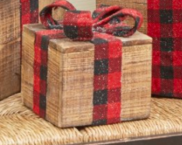
Story: Made for Love at Christmas
Matthew was a 10-year-old who lived with his aunt, a bitter woman who was annoyed with the burden of caring for her late sister's son.
I had not noticed Matthew until he began staying after class each day to help me straighten up the room. We did this companionably, not speaking much, enjoying the solitude of the afternoon. When we did talk, Matthew spoke mostly of his mother. Though he was young when she died, he remembered a kind, gentle, loving woman.
As Christmas drew near, Matthew stopped coming after school. I stopped him one afternoon and asked why, and said I missed him. His large brown eyes lit up eagerly as he replied, 'Did you really miss me?' I explained how he had been my best helper. 'I’m not coming because I am making you a surprise,' he whispered confidentially. 'It's for Christmas.' With that, he became embarrassed and dashed from the room.
Finally came the last school day before Christmas. Matthew crept into the room with his hands concealing something behind his back. 'I have your present,' he said timidly when I looked up. 'I hope you like it.' He held out his hands, and there lying in his small palms was a tiny roughly made wooden box. ‘Open it,’ he said.
'It's beautiful, Matthew.’ I said. I opened the box and saw it was empty. 'What is it, Matthew?' I asked gently.
'It's love,' he whispered. ‘Mother always said you can’t see it or touch it, but it’s the best gift of all.'
So now I keep a small crudely made box on my piano and smile when friends ask what's inside.

