Extra Articles Instructions
Below are three extra articles. To use one of these extra articles in your newsletter:
PRINT-FORMAT NEWSLETTERS
- Copy the text of an article below. Then paste it into an existing frame on your newsletter (highlight the existing text, then paste over it). You may need to edit the content to fit the space after pasting it.
- Copy the image separately, then paste it into your newsletter and move it into place using your mouse. You may need to edit the margins of your text to fit around your image.
EMAIL-FORMAT NEWSLETTERS
To use an article in the Mailchimp newsletter, copy and paste the text into your email newsletter (using a Text Block) and reformat as needed. Save the image to your own computer and upload it to your Mailchimp account.

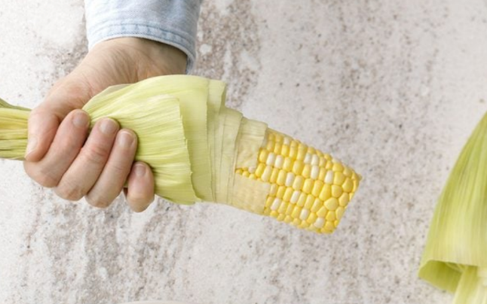
Summer Food Hacks
Shucking corn (when do we ever say "shucking" in any other context?) can be super time consuming and those strings can get messy. Use the magic of the microwave to eliminate both issues. Cut off the string end, then microwave your corn by itself (no water or wrapping) for 30 seconds to a minute on high heat. Voila! Corn shucked.
Love mangos, but hate peeling them? Use a potato peeler instead of a knife. You'll be able to remove strips of skin without hacking away so much of the fruit.
A bummer is buying fresh herbs and having them wilt the next day. Keep herbs like parsley and cilantro fresher by trimming the stems short, then placing the bunch upright into a short glass of water, covering just the stems. Then place a plastic bag over top and tie it off. Store in the fridge or on the counter for up to two weeks!


Why Summer Feels Like It Lasts Forever (When You're a Kid)
Remember when summer seemed to stretch on forever? There’s a reason for that. Psychologists say new experiences slow down our perception of time. Kids fill their summers with firsts—camps, bike rides, fireflies, and sleepovers. As adults, we fall into routines that speed things up. Want to make your summer feel longer? Try something new: visit a place you’ve never been, eat something unusual, or take a spontaneous day off. Novelty stretches time and makes better memories.


How Blood-Flow Boosts Brainpower
Your brain makes up only about 2% of your body weight, yet it consumes roughly 20% of your oxygen supply. That oxygen—and the glucose your brain also depends on—arrives via blood flow. When circulation is sluggish, so is your thinking.
Physical movement is one of the most effective ways to increase cerebral blood flow. Even light aerobic activity, such as walking or cycling, helps dilate blood vessels and deliver more oxygen-rich blood to the brain. This enhanced circulation improves cognitive functions like memory, attention, and decision-making.
In fact, a 2017 study in Cerebral Cortex found that just 10 minutes of light exercise significantly improved connectivity between brain regions associated with memory and learning. Another study in NeuroImage showed that aerobic fitness is linked to increased blood flow in the prefrontal cortex—the part of the brain responsible for planning and problem-solving.
The takeaway? Movement doesn’t just benefit your muscles—it sharpens your mind. So, if you’ve been sitting for a while, a short walk or stretching session may be exactly what your brain needs to reset and refocus.

