
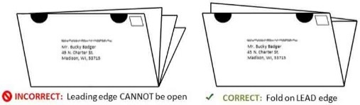
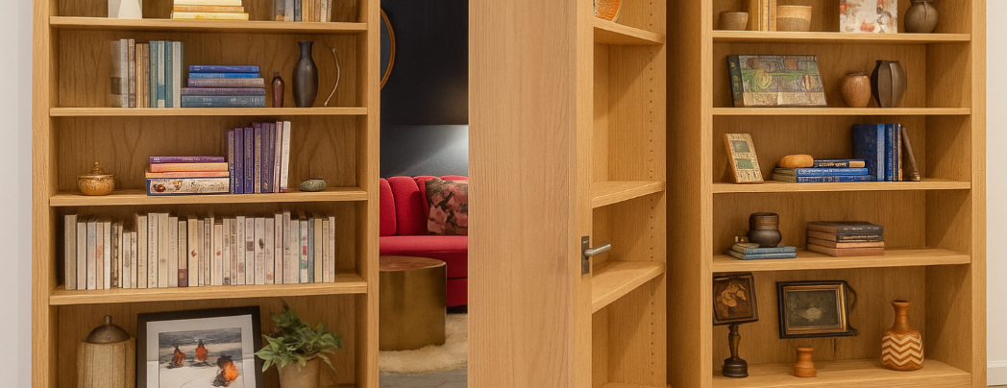






Upper Panel Instructions
1. You can use this area for mailing labels. See the image for the correct way to fold and tab your newsletters on Tabloid paper. Seal all the edges using tabs. (Printing Tutorial – Control + Click to view.)
2. You can use this area for content. If you don’t plan to mail the newsletters as self-mailers, then you can add your own content to this area instead of labels. First delete the back page title and return address.
To delete the yellow instruction boxes, click on
an edge of the yellow box, then click DELETE on your keyboard.
Canadian agents—drop this image over the top of the 4th of July image.
US agents—delete this Canada Day image.
Delete these yellow boxes or any image by clicking on an edge, then Delete on your keyboard.
To Insert Your Picture
Click once on the image to activate it. LEFT click, NOT right click!
Go to the INSERT tab on the edit ribbon at the top of the screen. Chose INSERT >> Pictures
Move and resize your image using your mouse. If the picture jumps to a new page, then CROP the image. Find the Crop function on the Picture Format menu, after clicking on the image.
Your Name | 555-333-2222 | Your Website

Your Name
Your Company
Address
Address
Real Estate License#

Shhh… This Home’s for Sale
Sometimes homes sell without ever hitting the public market — there's no Zillow listing, no For Sale sign, no stream of buyers traipsing through the house. These private deals are called pocket listings, and they can be quick.
But pocket listings come with a major trade-off: limited exposure. When your home isn’t listed openly on the MLS (Multiple Listing Service), it won’t show up on major search sites like Zillow or Realtor.com or be found by other Realtors who are working with active buyers. That means far fewer buyer eyeballs, and usually fewer and lower offers. In most markets, strong competition among buyers is what drives up price and reduces time on market.
Why would you even consider a pocket listing? They can make sense in certain situations, like when you need to sell quietly, or you have limitations that make showings difficult. However, they are risky from the perspective of getting the best offers. If an agent (or a neighbor) says he/she's got a perfect buyer for your home, you still may want to have a period of open listing, just to be sure.
Your selling strategy should match your goals. Let’s talk through the options and choose the one that makes the most dollars and sense for your situation.

Your Name

555-333-2222

email@emailaddress.com

This newsletter is for entertainment purposes only. Images are sourced from Canva.com. This information is solely for entertainment, and should not be substituted for medical, legal, financial or tax advice. Do not hold us responsible for actions you take without proper medical, financial, legal or tax advice. This is not intended as a solicitation of listed property.

How to Play (& Win) the Negotiation Game
There are many hidden strategies involved in negotiation. The more you know, the better positioned you are. Read now or text for a copy: ${Phone}

Do You Have a $25,000
To-Do List?
Happy July! With all the heat, are you feeling a mid-year productivity slump? A century-old trick might help. In 1918, steel magnate Charles Schwab asked a consultant how to get more done and be more efficient. The advice is something we take for granted today.
Each night, said the consultant, write down your six most important tasks for tomorrow — then tackle them. Schwab tried it, and it made such a huge difference that he paid $25,000 for the tip. That's over $500,000 in today's $. Making a list remains one of the best productivity tools in our arsenal. It works because, well, focus. Is your to-do list worth $25K?

What’s Your Next Move?
Whether you’re buying, selling, or just daydreaming, I’m here to help you think it through with the facts. Reach out anytime — no pressure, no sales pitch. Just solid advice. Any question is a good question.

555-333-2222



Secret Spaces Can Add House Value
Remember the thrill when Lucy stepped through the wardrobe into Narnia? Or the joy of seeing Diagon Alley beyond the wall of the Leaky Cauldron? Children’s stories tap into our natural love of mystery, hinting at adventure beyond the ordinary. It’s the same reason kids build blanket forts and secret clubhouses—hidden spaces feel magical.
Real homes may not come with portals to other worlds, but they sometimes have secret spaces. Some stately homes built before the 1900s have back staircases for servants, or crawlspaces between rooms, or even moving bookshelves that open into private halls with spyholes.
Now, after decades of more pedestrian home construction, hidden spaces are making a comeback—mostly just for fun. People are adding under-the-stair playrooms, double-layer pantries, hidden closets, secret wine cellars, and more! One open house recently showcased a loft with secret access—the agent offered a prize to anyone who could figure out how to climb up. No one could, that’s how cleverly hidden the stairs were.
Interestingly, hidden features like these may boost your home’s value. Zillow has found that homes with creative built-ins or secret spaces can sell for up to 30% above predicted value. Real estate agents say these features give a listing character and create a memorable “wow” factor.
If you're considering adding a secret space, work with someone who can finish the job with care. The charm is great, but craftsmanship is what really sells these features.

You’re the Best—Thanks!
I’m grateful to all of you who you have been part of my business world. A special shout-out this month to…
Thank you name 1
Thank you name 2
Thank you name 3

Quiz Contest - Win a FREE Coffee Card
Email me the answer to the question on page 2. Put the word QUIZ in the subject line. email@emailaddress.com
- Last month's Q&A: A child builds three sandcastles side by side, but when the tide comes in, only two are destroyed. How can that be? They're built perpendicular to the shoreline.
Congratulations to last month’s winner!
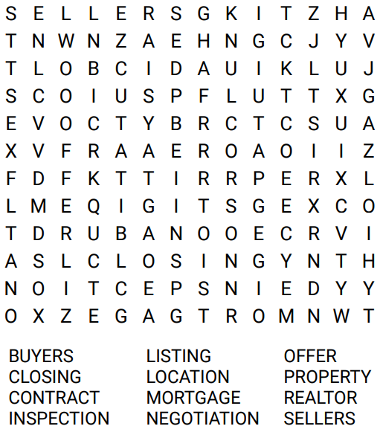
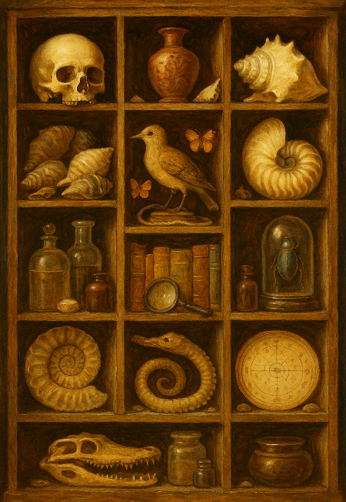
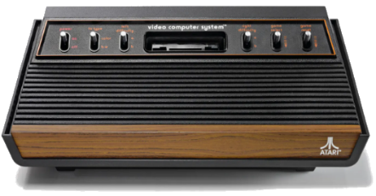
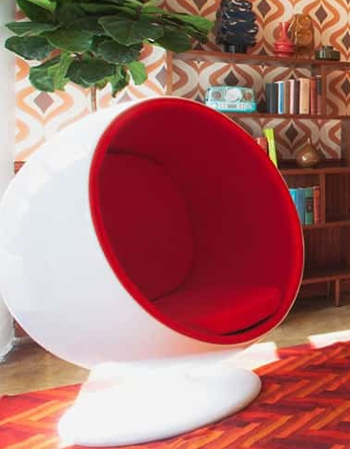

July 2025 Your Name | 555-555-5555

AI Update—Atari Beats ChatGPT at Chess!
OpenAI’s ChatGPT was recently challenged to a “beginner-level” chess match against a 1979 Atari Video Chess emulator. The old console crushed AI. With only a 1.19 MHz CPU and 128 bytes of RAM, the Atari’s simple one-or-two moves ahead engine outmaneuvered ChatGPT, which misread positions, mistook rooks for bishops, and lost track of pieces. The AI “made enough blunders to get laughed out of a 3rd grade chess club,” according to engineer Robert Caruso, who moderated the 90-minute game.
The experiment highlights an AI limitation: language models lack dedicated logic and long-term state tracking. According to ChatGPT, its strengths are understanding and generating human-like text, explaining content, writing code, and answering questions. However, it is not good at tasks requiring long-term memory, precise logic, or structured gameplay, such as keeping track of a chessboard or planning several moves ahead.

Real Estate Word Search

5 Tricks to Selling Faster This Summer
If you’re planning to sell this summer, you’ve probably heard the usual advice: repaint the walls, mow the lawn, declutter everything. All good tips, but also ordinary and expected. What really helps a home sell fast in the heat of summer are these things…
1. Give buyers a reason to linger. Forget about the granite countertops for a second. What buyers remember is how a place made them feel. If it’s 94 degrees out and they walk into a pleasantly cool house with an iced pitcher of lemonade and quiet music playing, they’ll mentally unpack their bags before they’ve even seen the upstairs. Selling is emotional. Make them want to stay. Make the space inviting.
2. Ditch the air-fresheners. Buyers are suspicious of perfumy smells. A blast of “Crisp Linen” from a plug-in diffuser tells people you might be hiding something. Also, many buyers are sensitive to artificial odors. Open windows early in the day to let fresh air circulate and then shut them mid-morning to lock in the coolness.
3. Don’t list on Friday. I wouldn’t recommend it. If you do, your home gets buried under a pile of other “Just Listed” properties in buyers’ inboxes. Better is to list on a Tuesday or Wednesday. It gives your listing breathing room, and the most motivated buyers are keeping a sharp eye out for mid-week listings.
4. Cool the outside vibe. Yes, buyers are buying a house, but they’re also buying a yard or patio or deck (if you have one). Dress the outdoor space to advantage! If you’ve got a shady patio, add plants that turn it into a secret garden. Make your deck say “sit a while” with colorful Adirondack chairs and a side table. Freshen up the balcony. Nothing says “deferred maintenance” like a wobbly railing!
5. Price it like you mean it. Summer buyers don’t have time to mess around. They’re thinking: “Can we move in before school starts?” “Can we get in before it gets cold again?” An overpriced home wastes their time — and yours. A fair price compared to other homes will bring you more and better offers. You want offers, not lookers.

Walk-Time Multiplier for Health
Are you a walker? If you are, then here's a way to get twice as much bang for your walking buck. You may be familiar with the concept of high intensity interval training. That means doing an exercise at a normal pace, then breaking into a high intensity pace for a short time, then returning normal.
Applied to walking, this means keeping a modest, steady pace for about 5 minutes, then breaking into a high-intensity fast-walk for 2-3 minutes, then dropping back to your lower walk pace. Keep alternating throughout your walk to see a dramatic difference in heart health and weight control for the same time spent walking!

Curvy Is Back in Fashion
In mid-century 1900’s, curvaceous design was all the rage. We had round fireplaces, arches, spiral staircases, and egg chairs. Then we became squares, with decor that emphasized blocky shapes. Now, according to Pinterest, we’re trending curvy again, with a 140% spike in searches for “curved walls” and “arched doors.”
Why the love of curves? Psychologists say they evoke feelings of calm and whimsey. One homeowner who added an arch between his kitchen and dining room, called it “the best vibe upgrade we ever made.” Perhaps because we’re keeping our homes longer, we’re more interested in remodeling in unique ways—with more curves, hidden spaces, and bold design.

Create Your Own ‘Cabinet of Curiosities’
In a dusty Arizona town, there's a 10 x 16-foot shack (about the size of a bedroom) that advertises itself as the world’s tiniest museum. Inside, they've collected rotary phones, vintage metal lunchboxes, and handwritten notes from strangers — all displayed with quiet pride. It’s a modern echo of something much older: the cabinet of curiosities. A cabinet of curiosities was a collection of oddities like fossils, trinkets, preserved animals, foreign tools, etc., usually from a wealthy individual's scientific travels. There was no requirement for usefulness or perfection. The point was to spark curiosity.
We can each create something like this in our own homes. A shelf of old postcards. A shadowbox of beach finds. A bowl of old keys. These little displays don’t have to be functional. They only need to preserve what fascinates us. Because a home isn't just a place to live — it’s a place to dream and experience.
Name three numbers (none of them zero) that give the same result when added together as they do when multiplied together.
(A + B + C = A x B x C)

July Quiz Question

