# Extra Articles Instructions

Below are **three** extra articles. To use one of these extra articles in your newsletter:

**PRINT-FORMAT NEWSLETTERS**

1. Copy the text of an article below. Then paste it into an existing frame on your newsletter (highlight the existing text, then paste over it). **You may need to edit the content to fit the space after pasting it.**
2. Copy the image separately, then paste it into your newsletter and move it into place using your mouse. **You may need to edit the margins of your text to fit around your image.**

**EMAIL-FORMAT NEWSLETTERS**

To use an article in the Mailchimp newsletter, copy and paste the text into your email newsletter (using a Text Block) and reformat as needed. Save the image to your own computer and upload it to your Mailchimp account.

# A blue text on a black background AI-generated content may be incorrect.The Origin of Father's Day

Father’s Day as an "official day," is celebrated on the third Sunday of June in over 20 countries. The tradition originated in the United States in the early 1900's when Sonora Smart Dodd was inspired by Mother's Day to recognize her father, a US Civil War veteran and single parent who raised six children. It wasn’t until 1972 that President Richard Nixon made Father's Day a National Day of Celebration. From there, the day gradually spread to other countries through community events and commercial promotions.

# A Smart Home Feature of the Early 1900s

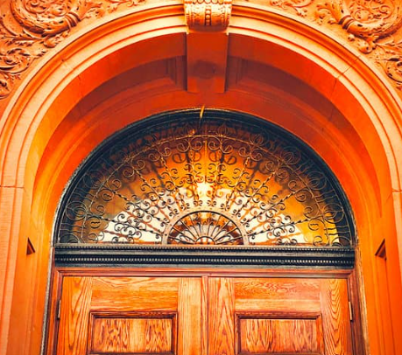Have you ever seen a Craftsman or Victorian home or an old store front? You might have noticed they often have transom windows, which are narrow windows above the doors. Like a big flap, they can be opened by a long pull-rod. Some are plain glass, others have fancy stained-glass designs that add flair.

They started out as a clever fix before air conditioning was a thing, by letting hot air escape and generating air flow even when the door was shut. Think of them as the original smart home feature.

These days, transoms are more about style than airflow. They bring in extra light, make ceilings feel taller, and add a touch of charm. You can add a transom to your own home, if you think it would add a touch of historical character.

# The Rise of the Tiny Library Movement

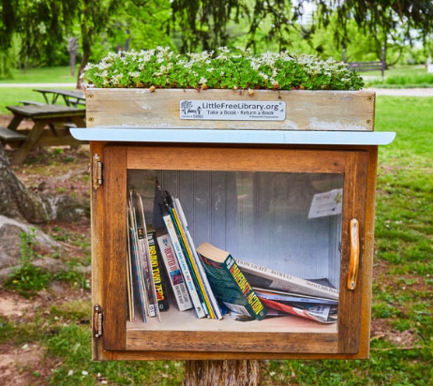Have you seen those tiny book-sharing boxes in front of people’s houses? They’re often hand-made and styled to look like miniature houses. This is called a tiny library, and there are organizations that help foster tiny libraries all over the world. But how did it start? *Little Free Library*, has registered over 100,000 book-sharing boxes in more than 100 countries, and you’ll even see them marked on maps, as if they’re actual shops. Many are homegrown and unregistered, built by individuals who simply want to share their love of reading. Anyone can create a tiny library.

It started with a simple idea: take a book, leave a book. The trend began in 2009 when Todd Bol of Wisconsin built a miniature schoolhouse-shaped box in honor of his late mother, a teacher who loved books. He filled it with books and set it on a post in his yard. Neighbors loved it, and the idea spread like wildfire locally and through social media.

Why are they so popular? These small libraries offer more than free books—they create a sense of connection. They turn front yards into community hubs, spark conversations among strangers, and give gently used books a second life. In a world increasingly online, tiny libraries bring back the charm of analog sharing.