

Your Name | 555-333-2222 | Your Website

Moving Fast
Thinking of selling? The market moves fast—but so do I. Contact me to discuss your priorities.

555-333-2222





Which seller concessions have the highest perceived value for the lowest cost?
Find out here, or text me for a copy.

Ice Cream Is Cool
In the 1970s, kids could ride their bikes to the corner drugstore, hand over a nickel, and get a big scoop of Tutti Frutti ice cream. Or maybe butter brickle, black walnut, or orange sherbet—popular flavors of the day. Good luck finding them now.
Back then, you might’ve gotten your cone from a soda fountain or a Woolworth’s lunch counter. But as creative brands like Ben & Jerry’s arrived, tastes began to change. Today’s top picks include cookie dough, cake batter, and rocky road. What’s your favorite?
Did you know you can make ice cream at home without an ice cream machine? Google it or look up 4 Ways to make Ice Cream Without an Ice Cream Machine by Nate Bakes.

Show What You Know
I was reading an article that nailed something many of us experience—the gap between being certain about something and showing up like we’re certain. Instead of projecting confidence, we back off, giving in to modesty or second-guessing, without stepping fully into our power. Modesty can feel safe, but it often leads to a quiet erosion of confidence and missed opportunities. After all, if we don’t acknowledge our strengths, we can’t expect others to.
If you recognize yourself in this, here are a few things to try:
Acknowledge your knacks. As in, “I have a knack for spotting problems,” or “...for making others feel good,” or “...for numbers.” We often overlook our own strengths. It’s not about being loud or opinionated—it’s about recognizing the contributions of our abilities.
Build structure around fear or weakness. Notice where you second-guess yourself, then delegate, automate, or create systems. For example, “I’m not direct, so I’ll write out my advice ahead of time.” Don’t always fight fear—instead work around it. No one is good at everything.
Channel someone certain. Find someone who radiates confidence and model their self-assurance until yours builds. TV shows like The Men Who Built America or Titans That Built the World offer bold, unapologetic examples. So do novels like Atlas Shrugged or The Queen’s Gambit. Or maybe someone you know—a boss or a close friend—has the kind of confidence you’d like to mirror. Find your own models.


How Do Condos Set HOA Fees —
and Why Are Some So High?
If you're buying a condo, you're familiar with the idea of an HOA fee (Homeowner’s Association). What exactly are you paying for—and who decides that number?
Condo fees are set by the association’s board, along with an accountant. The board is typically made up of fellow owners
whose job it is to create a budget that covers the building’s
shared expenses: insurance, exterior maintenance, landscaping, snow removal, elevator servicing, pool care, water fees, and trash collection. If the condo has amenities like a gym, Wi-Fi, or 24-hour security, expect those to be factored in too. Consider these to be shared expenses you'd need to pay entirely yourself if you owned a separate house. Paying an HOA fee of $300 to $500/mo. might be a bargain compared to maintenance on a house.
Part of your fee also goes to a reserve fund—savings for future repairs like a roof replacement. If that fund is too low and an emergency hits, the board may issue a special assessment to cover the shortfall.
The HOA fee can also include an HOA management company cost, which can sometimes raise the HOA fee considerably. That, plus special assessments, may account for higher HOA fees in seemingly similar complexes.
Before buying, assess the strength of the HOA. Check the condition of the buildings—visible disrepair could be a red flag. Ask about the reserve fund, upcoming assessments, and potential insurance increases, especially in disaster-prone areas. Ask whether management fees are included or if the board plans to hire a new management company. Always request the latest HOA meeting minutes and review them for any concerns.
Getting a full picture of an HOA isn’t always easy. Budgets and meeting minutes aren’t always available before an offer—and they’re not always easy to interpret. If I’m representing you, I’ll gather those details and connect you with someone on the board. Finally, if you see residents out and about—ask them what it’s like to live there. You might get interesting answers. Contact me to start your condo search.

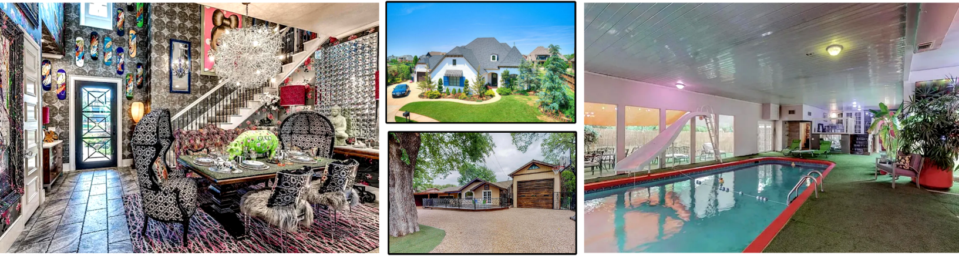

The Best Thing about Owning a Home!
Arguably the best thing about owning your home is being able to do what you want behind closed doors. That includes decorating how you want, even if that means leopard print wallpaper and pink and black stripes. You might be surprised by how often a home looks like one thing from the outside, but something totally different inside. Here are two examples! How many of us are brave or talented enough to decorate or remodel like this? Want to see more? Search Google for "crazy home interior images". They’re not all crazy, just fun to the tastes of the owners.

A child builds three sandcastles side by side, but when the tide comes in, only two are destroyed. How can that be?

June Quiz Question

Quiz Contest - Win a FREE Coffee Card
Email me the answer to the question on page 2. Put the word QUIZ in the subject line. email@emailaddress.com
- Last month's Q&A: Which character is first to speak in the original “Star Wars” movie? C3PO
Congratulations to last month’s winner!

Thank you, friends!
I’m grateful to all of you who you have been part of my business world. A special shout-out this month to…
Thank you name 1
Thank you name 2
Thank you name 3

June 2025 Your Name | 555-555-5555

${First Name} ${Last Name}


Ever Wonder How Generations Get Named?
Most of us recognize generation names, such as Baby Boomers, named for the boom of babies born to soldiers returning from WWII. Subsequent writers began referring to the generation after Boomers as Generation X, meaning not anything specific. In the late 1990s and early 2000s, the obvious choices were Gen Y (AKA Millennials) and Gen Z, mostly created for marketing purposes.
In 2008, Mark McCrindle, an Australian social researcher, coined Gen Alpha to continue the sequence after Gen Z. He chose Alpha, the first letter of the Greek alphabet, to mark a new beginning—symbolizing the end of generations born in the previous century.
Briefly (because you're wondering), the labels are roughly: Baby Boomers (1956-1964), Gen X (1965-1980), Gen Y/Millennials (1981-1996), Gen Z (1997-2009), Gen Alpha (2010-2024), Gen Beta (2025-3039).
These are general markers, not rules and may differ depending on which sources you look at.

Summer Fun Word Search
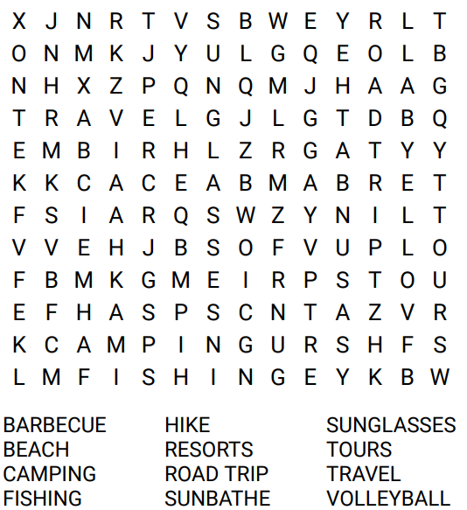


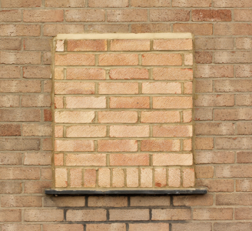

Time for Road Tripping!
It’s that time of year again…time for a road trip! As you know, done right, the trip itself is a vacation, not just a destination. Here’s a reminder to whet your appetite…
To make a perfect road trip, gather the perfect kit: Load up on trail mix, jerky, fresh fruit, or something like gummy worms. Bring a cooler, pillow, first-aid kit, and roll of duct tape (trust me). Don’t overschedule—look for random detours for roadside oddities, stretch your legs at scenic overlooks, and say yes to stopping at old diners. You never know what you’ll find.

How Taxes Shaped Architecture
Ever wonder why some historic homes have bricked-up windows? In 18th-century England, houses were taxed based on number of windows,
so people made them part of the walls to save money.
In Amsterdam, houses were taxed on width, leading to the city’s famously narrow, tall homes with steep stairs.
In France, roof taxes led to steep, elaborate attics—because technically, attics weren’t taxed as floorspace!



Your Name
Your Company
Address
Address
Real Estate License#

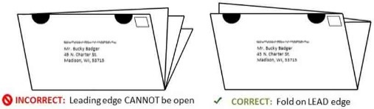
Upper Panel Instructions
1. You can use this area for mailing labels. See the image for the correct way to fold and tab your newsletters on Tabloid paper. Seal all the edges using tabs. (Printing Tutorial – Control + Click to view.)
2. You can use this area for content. If you don’t plan to mail the newsletters as self-mailers, then you can add your own content to this area instead of labels. First delete the back page title and return address.
To delete the yellow instruction boxes, click on
an edge of the yellow box, then click DELETE on your keyboard.

To Insert Your Picture
Click once on the image to activate it. LEFT click, NOT right click!
Go to the INSERT tab on the edit ribbon at the top of the screen. Chose INSERT >> Pictures
Move and resize your image using your mouse. If the picture jumps to a new page, then CROP the image. Find the Crop function on the Picture Format menu, after clicking on the image.

Can We Skip the Final Walkthrough?
It can be tempting. After all, the sellers were nice people and you're tired of the stress of buying. Big mistake! The final walkthrough is literally the last opportunity you'll have to make sure the house you are buying is still the house you agreed to buy.
You’d be surprised what can happen in the final days right before a home closes: Light fixtures mysteriously vanish, movers gouge the hardwood floors, huge piles of debris get dumped into the vacant yard, or squatters decide to trash the place. I’ve seen it all. It's not always the seller's fault, but the seller will likely be on the hook for it; it was their responsibility to secure the property (something I work with my sellers to ensure!).
You should do the walkthrough no more than 48 hours before you sign the closing papers. Turn on every light, test every appliance, run the faucets, flush the toilets (yes, I've seen sabotage like concrete poured into toilets), and check that every repair was done as promised. If something’s off, it’s a lot easier to resolve before you sign the final paperwork, while you still have leverage. I've got a checklist to help you cover the
possibilities when you get to that point in your purchase.

Your Name

555-333-2222

email@emailaddress.com
This newsletter is for entertainment purposes only. Images are sourced from Canva.com. This information is solely for entertainment, and should not be substituted for medical, legal, financial or tax advice. Do not hold us responsible for actions you take without proper medical, financial, legal or tax advice. This is not intended as a solicitation of listed property.

