Getting Homeowners Insurance Right
Homeowners insurance can feel like a “necessary evil,” but it serves a saintly purpose — to protect you. Since you have to pay it every month, the trick is to pay as little as possible for as much coverage as possible. Here’s what to look for.

Do You Need Homeowners Insurance?
If you own your home free and clear, you’re not legally required to have homeowners insurance (sometimes called hazard insurance). But if you have a mortgage, your lender will require it as a condition of the loan. Here’s how to shop smart and compare quotes.

What Is a Homeowners Insurance Quote?
A quote is an estimate of the price you’ll pay for a policy, usually listed as a yearly, six-month, or monthly amount. When comparing quotes, make sure you’re comparing apples to apples — look at coverage limits, deductibles, and add-ons.
Your quote will depend on your home’s size, location, replacement value, condition, and proximity to a fire station. Each company uses its own formula, so prices can vary widely. You’ll boost your chances of finding the best deal by getting at least three quotes — the difference can be hundreds of dollars a year.
Remember, a quote is just an estimate. The actual premium may change slightly once the policy is finalized, but it should be close.

Who Provides Homeowners Insurance?
Many companies provide homeowners insurance, including those that may already insure your car. Common examples include State Farm, Allstate, Farmers, USAA, Liberty Mutual, Nationwide, and Travelers.

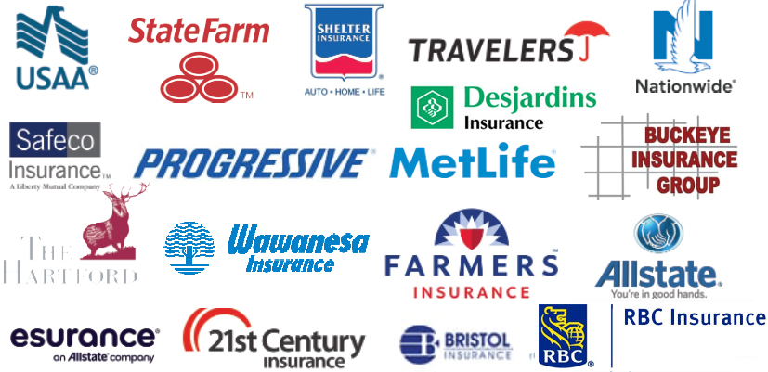

What Does Homeowners Insurance Cover?
Homeowners insurance protects you from major financial losses due to damage or liability. Standard policies typically include:

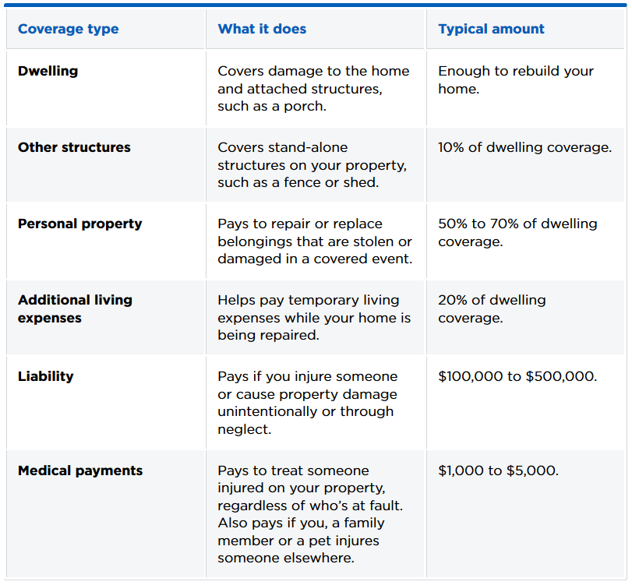

Coverage limits can vary widely. For instance, if one policy includes $8,000 in additional living expenses and another offers $6,000, the first may be a better value — assuming all other factors are equal.

Why Prices Differ
Several factors affect your premium. When comparing quotes, make sure you use the same criteria across companies:
- Deductible – the amount you pay out of pocket before your insurer covers a claim. Common deductibles range from $500 to $2,000. A higher deductible lowers your premium but increases your risk.
- Flood, earthquake, or windstorm coverage – standard policies don’t cover flood or earthquake damage, and windstorm coverage may be limited in hurricane-prone regions. Ask about optional add-ons if you live in a high-risk area.
- Replacement cost vs. actual cash value – standard coverage may only pay depreciated value for lost items. Upgrading to replacement cost coverage ensures you get enough to replace items with new ones.
- Extended or guaranteed replacement cost – helps if rebuilding costs exceed your dwelling coverage limit, which can happen after disasters or inflation spikes.

How to Get a Home Insurance Quote
You can call a local agent or broker who can give you a quote and answer questions about local risks. Or, you can visit company websites and use their online quote forms. Many people prefer talking to an agent, since online forms can be confusing or incomplete — but it’s smart to get at least one online quote for comparison.

Final Thought
Homeowners insurance isn’t exciting, but it’s essential. Taking time to compare quotes could save you hundreds of dollars a year — and protect the investment you’ve worked so hard to build.
KNOW SOMEONE WITH QUESTIONS ABOUT BUYING A HOME? PUT THEM IN TOUCH WITH ME FOR HELP.

