Extra Articles Instructions
Below are three extra articles. To use one of these extra articles in your newsletter:
PRINT-FORMAT NEWSLETTERS
- Copy the text of an article below. Then paste it into an existing frame on your newsletter (highlight the existing text, then paste over it). You may need to edit the content to fit the space after pasting it.
- Copy the image separately, then paste it into your newsletter and move it into place using your mouse. You may need to edit the margins of your text to fit around your image.
EMAIL-FORMAT NEWSLETTERS
To use an article in the Mailchimp newsletter, copy and paste the text into your email newsletter (using a Text Block) and reformat as needed. Save the image to your own computer and upload it to your Mailchimp account.

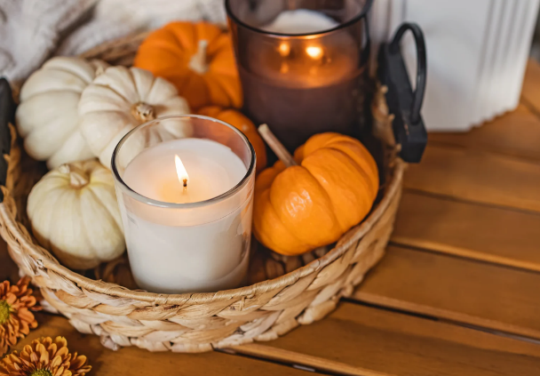
Autumn cozy, not zombie apocalypse
For some, Halloween decorating is pure joy; for others, it’s just one more chore on the seasonal to-do list. Either way, it’s worth remembering that less can be more. Instead of covering every inch with webs and skeletons, try a few simple touches: a cluster of pumpkins, a harvest wreath, or soft amber string lights. These create a festive feel without the cleanup nightmare. Overdoing it can make your space look cluttered or even a little creepy. The sweet spot? Décor that makes your home feel warm, inviting, and cozy—more autumn charm than monsters and gore.


Tips for clearing your mind
Mental clarity isn’t just about meditation cushions and quiet rooms—it’s also about clearing the mental clutter we carry every day. We live in a world of constant noise: pings from phones, half-finished tasks, and thoughts pulling in twelve directions at once. The result? Foggy focus and low energy.
The solution is simple: do less, better. Easy to say, but harder to do. The first step is getting excellent sleep. Consider a sleep inventory of your room and get rid of noises and light. Second, cut commitments that drain you—not just to others but also to yourself and your work. Then, tackle one task at a time instead of juggling five.
Even a ten-minute walk without headphones helps reset your brain. Some people swear by journaling or mind mapping—both force scattered thoughts into clear lines on paper. The truth is, you’ll never have mental clarity by accident. You have to choose it. Protecting your focus is the grown-up version of protecting your time. And once you do, you’ll find yourself calmer, sharper, and more effective in every area of life.

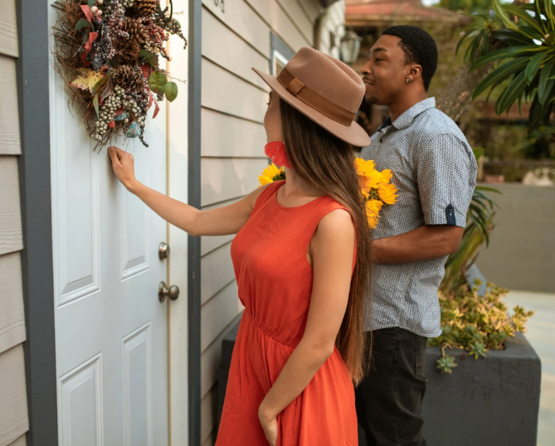
Would you knock on a stranger’s door to ask if they want to sell?
In competitive markets, buyers often feel like they’re one step behind—homes list on a Thursday and sell by Monday. One way to get ahead? Knock on doors or send letters in the neighborhood where you want to live. It sounds old-fashioned, but sometimes it works.
The upside is obvious: you may connect with a homeowner who’s been toying with the idea of selling but hasn’t listed yet. They get a potential buyer without dealing with open houses, and you get a shot at a home before the crowd piles in. It can also signal your seriousness—neighbors see you’re willing to go beyond the usual Zillow scroll.
The downside? Some homeowners won’t appreciate an unexpected knock or letter and they’ll be suspicious even if they are interested. Also, you will likely spend days (or weeks) knocking before finding that one person who might be interested. You’ll find plenty who’ll say maybe, but not for a year or two yet.
A better option is to ask me to do that leg work for you. If you know you’re qualified for that community, and are ready to buy, then I can approach homeowners with more authenticity to submit a valid offer. Let me know if you’d like me to go that extra mile for you.

