Extra Articles Instructions
Below are three extra articles. To use one of these extra articles in your newsletter:
PRINT-FORMAT NEWSLETTERS
- Copy the text of an article below. Then paste it into an existing frame on your newsletter (highlight the existing text, then paste over it). You may need to edit the content to fit the space after pasting it.
- Copy the image separately, then paste it into your newsletter and move it into place using your mouse. You may need to edit the margins of your text to fit around your image.
EMAIL-FORMAT NEWSLETTERS
To use an article in the Mailchimp newsletter, copy and paste the text into your email newsletter (using a Text Block) and reformat as needed. Save the image to your own computer and upload it to your Mailchimp account.

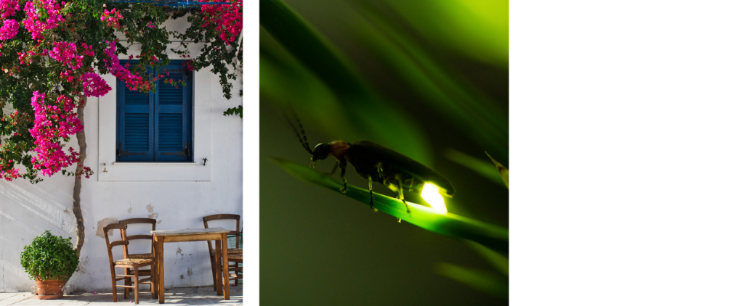
The Value of White Walls in Hot Climates
From Greek island cottages to desert adobe homes, whitewashed walls dominate hot climates. The reason is both practical and cultural. White surfaces reflect sunlight instead of absorbing it, keeping interiors cooler and reducing energy needs. In contrast, darker exteriors trap heat. But beyond physics, white walls carry symbolic value. In Mediterranean cultures, limewash wasn’t just reflective—it also acted as a disinfectant, believed to protect against disease. The result was entire villages gleaming under the sun, their brightness becoming part of the cultural identity. Today, many people adopt white interiors for their “airy” and minimalist look, echoing a tradition born from necessity.

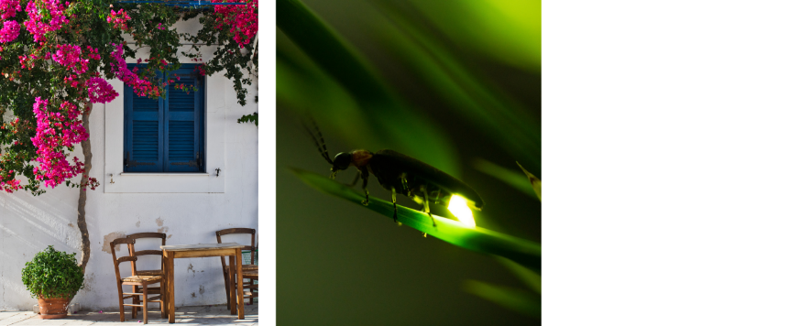
Fireflies Glow for Two Reasons
With summer winding down to fall, the fireflies have gone to wherever they go in the winter. The signal lights of summer are tucked away, waiting for next summer when the chemical reaction in their abdomens (involving luciferin, oxygen, and enzymes) starts flashing again. Each species of firefly (or lightning bug) has a unique light pattern, used to attract mates and ward off predators. Predators often avoid eating fireflies because their glowing compounds taste bitter, making the flash a survival tactic as well as a mating call.

How Some Colors Can Make a Room Feel Warmer or Cooler
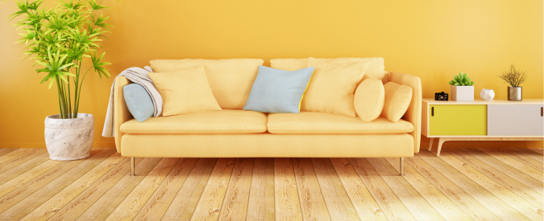
Color theory plays a surprisingly physical role in how we experience spaces. Warm hues like red, orange, and yellow are associated with fire and sunlight, which makes them feel energizing and cozy—ideal for dining rooms or social spaces. Cool hues like blue and green recall water and sky, creating calmness and making rooms seem more spacious. What’s fascinating is that the effect is partly physical: warm colors can subtly raise heart rate and blood pressure, while cool colors can lower them. That’s why prisons and hospitals sometimes use pale blues to reduce tension (though the choice of “institutional green” may have other counter-productive effects, too). In homes, thoughtful color choice doesn’t just shape aesthetics; it alters mood and even perceived temperature.

