*Armed with Knowledge:* What NOT TO UPGRADE BEFORE SELLING YOUR HOME

## **Unless you plan to completely renovate your home, chances are you'll only be making partial upgrades before selling. Which ones do you choose? Which will attract a buyer, increase your profit, and pay for themselves vs. being an unnecessary waste of time and money?**

While all upgrades should at least pay for themselves, there is a diminishing return. There's no sense in doing work that won't result in a faster sale or more money.

Keep in mind this rule of real estate: The faster a home sells, the closer to your asking price it sells for; the slower it sells, the more the final offer drops. Many upgrades may help your home sell faster, but not for more money than market value.

With that in mind, here are some thoughts about what upgrades to skip and what to focus on instead:

# KITCHENS

If you have an older kitchen with dated cabinets and a stained countertop, will putting in $3,500 worth of shiny new appliances make a difference in your sales price or speed of sale? Some buyers will care, but most will probably say "Thanks," and then start thinking about how much they have to remodel the entire kitchen to match.

Will re-facing the cabinets matter? Only if the rest of the kitchen already looks updated. In other words, partially remodeling a kitchen might just be a waste of money. The exception is that if you have only one ugly/outdated element in the kitchen, and everything else looks fantastic, then consider upgrading that one element.

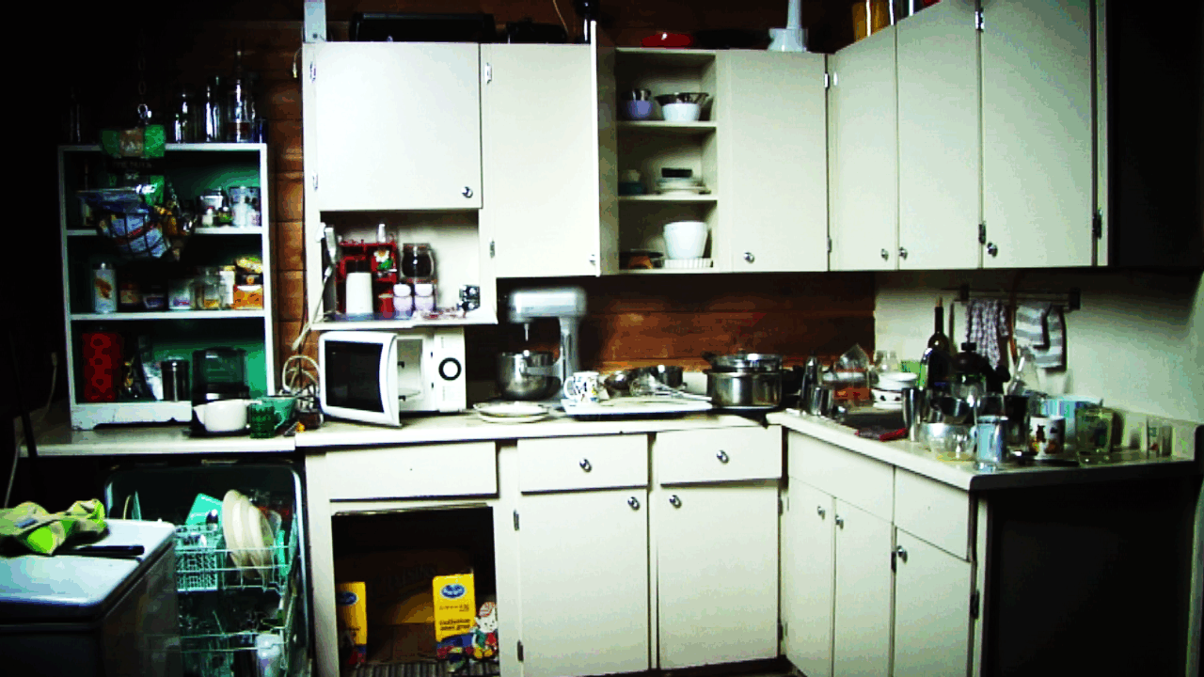A better choice for a dated kitchen might be to professionally clean the kitchen and appliances so everything smells great. Or remove old appliances altogether, and super-clean the empty spaces. Then paint all wall spaces in the kitchen that show.

If you can afford it, add a new faucet to the sink and a new range hood, especially if your old one looks grease-caked. These things tell buyers that you have maintained the home, and people can imagine themselves cooking there while they fix it up to their tastes.

# EXTERIOR PAINT

Like any other upgrade to your home, painting the entire exterior only matters in context of the whole. If your home is nicely updated everywhere except the exterior paint, then painting will matter. But if your roof is 40 years old and looks like it might leak in a dozen places, or if your windows are cracked, or your gutters are sagging, then painting may not make a difference.

In this case, you'd get more sales mileage out of repairing obvious problems. Strip and touch up badly peeling paint, fix popped siding, repair a cracked pane, tie up or cut dangling wires, clean or remove gutters, wash the dirt off your siding using your garden hose, etc. Make a list of everything you can reasonably do to the exterior, financially and physically, and then do what you can.

Cleaning up the exterior might make more of a difference than painting it. A clean exterior won't necessarily make it sell for a higher price, but it may make it sell faster. And as you know, a faster sale usually means a better price than a slower sale.

# LANDSCAPING

Like the exterior paint, landscaping can be daunting if it's been let go. If your home is in great shape, but your landscaping is awful, then it might make sense to invest in re-sodding or planting a new flower garden and adding mulch.

But if your landscaping is as dated as your house, then the best thing to do is tidy it up. Trim everything from the grass to the trees. Get rid of anything that's obviously overgrown, like huge box hedges or ivy. Don't worry about planting a beautiful garden. However, a splash of flowers in a flowerpot near the door will add a nice touch.

# ROOF

If the home is in otherwise great shape, then replacing the roof might be worthwhile. On the other hand, it might not matter. The market will tell you what to do. Have your agent do an analysis. In a hot market, you may be able to sell for top dollar without replacing the roof.

For instance, if your neighbors' homes are selling for $300,000 with good roofs, you might be able to sell your home for $295,000. Your loss of $5,000 might be a lot less than the cost of a new roof (often $12,000 plus).

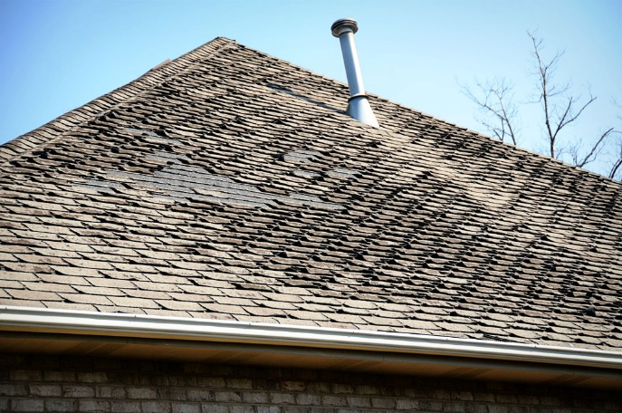However, in a slower market, if the roofs are all in great shape on every home for sale except yours, then you may need to replace the roof, or price much less than the cost of replacement.

For example, if ten homes are for sale in your neighborhood at $300,000 each, and they all have nice roofs, then you'll have to either replace your roof to get $300,000, or you'll have to price it lower than the cost of a new roof (maybe $280,000 for a $15,000 roof, which would be a loss of $5,000). Let the market guide you.

# BATHROOMS

Should you replace a stained bathtub or shower surround? Don't bother. Unless you go all out and remodel the entire bathroom, you won't make your money back on replacing the tub or shower surround.

Consider replacing old shower doors or resurfacing the tub for a fraction of the cost. Consider upgrading the light fixtures and faucets. They don't have to be expensive, just new. Remember, you're only trying to sell the home!

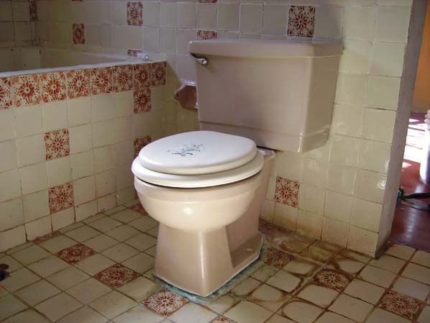Nothing turns a buyer off faster than a stained toilet and area around the base of the toilet. It's usually not too expensive to install a new toilet and seat ($150-$300). While it may not make people rush to give you offers, a new toilet at least won't push people away. Like the kitchen, clean, clean, clean your bathrooms.

# POPCORN CEILINGS

If you have an old popcorn ceiling (either asbestos or Styrofoam), only remove it if everything else in the home is lovely. An alternative to removal is to have the ceiling spray-painted white. (You'd probably only do this if your home was empty and the painters could cover the floors and walls with drop cloths.) Painting a 500 square foot ceiling might cost $500, while removing the popcorn might cost $2,500. All this depends on who does the work for you, or if you do it yourself.

# FLOORING

Should you replace or refinish the carpet, tile, or hardwoods? This is a balancing act question. Tile is very expensive to replace. Carpet not so much. Instead of replacing dirty, broken, or dingy tile, consider having it professionally cleaned. Only consider replacing it if the rest of the bathroom is in great condition and the floor tile is the only thing holding it back.

When it comes to hardwoods, again, you need to balance the condition of the floors against the overall condition of the rooms. It the hardwoods are the only thing holding it back from getting top dollar, then spending $5,000 to refinish the hardwoods might make sense. At least you might be able to recoup that $5,000 and sell faster to a better buyer who isn’t going to demand cash later for the floors.

When it comes to carpet, if it was expensive when installed in the 1960s, chances are it doesn't look expensive now. If you can afford low-cost replacement carpeting, it will help you sell your home. But if everything looks equally dated in the home, then cleaning your old carpet may be enough, since it’s likely the new buyers will want to replace the carpet anyway.

# INTERIOR PAINT

Don't bother repainting over colorful walls if your paint job looks good. Ignore the advice to repaint in neutral colors. A tastefully done green kitchen looks fine, for instance. Or a cobalt blue accent wall in a kid's room, or a soft purple wall in a library. The key is TASTEFUL. That can be subjective, so get multiple HONEST viewpoints on the color.

If you've chosen garish, primary, or dark colors for entire rooms, you'll want to repaint those in lighter colors. A dark room tends to drive buyers away. Also, if any of your walls look dingy with the passage of time, painting them a fresh light color will do wonders.

If you're a DIY painter, sloppy edging and splotchy patches will turn people off. In a hot market, sketchy painting might not matter as much, 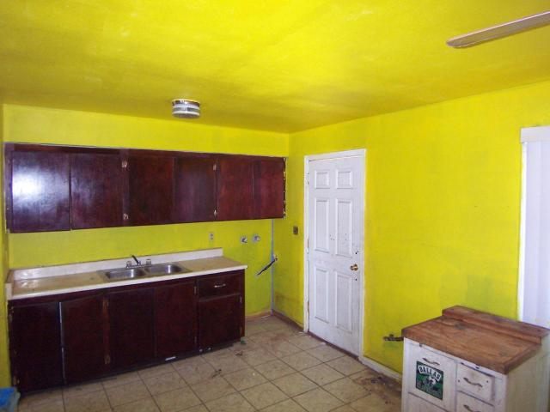because people are willing to repaint if it means landing a good house. But in an average or slow market, it might turn people off.

**CONCLUSION**

As you can see, the kind of upgrades you do are subjective. The right approach is to consider the whole house, the real estate market around you, your selling goals, and more.

## **Let's walk through your home TOGETHER AND compare it to others for sale in your area. That way, we can identify your highest-return upgrades, and figure the right strategy to sell your home for the most profit. Call to set a walk-through appointment.**