Extra Articles Instructions
Below are three extra articles. To use one of these extra articles in your newsletter:
PRINT-FORMAT NEWSLETTERS
- Copy the text of an article below. Then paste it into an existing frame on your newsletter (highlight the existing text, then paste over it). You may need to edit the content to fit the space after pasting it.
- Copy the image separately, then paste it into your newsletter and move it into place using your mouse. You may need to edit the margins of your text to fit around your image.
EMAIL-FORMAT NEWSLETTERS
To use an article in the Mailchimp newsletter, copy and paste the text into your email newsletter (using a Text Block) and reformat as needed. Save the image to your own computer and upload it to your Mailchimp account.


Mini procrastination hacks
There is evidence for something called the Zeigarnik Effect, which is an intrusive cognitive “need” to complete a task once it has been started. The uncomfortable cognitive struggle is only terminated once a person returns to the task. Now you know why you feel distracted when you procrastinate; it literally causes a physiological drag on your consciousness.
If you tend to procrastinate, here are two often cited “hacks” for getting on with it:
- Start using a timer. If you avoid tasks like cleaning the house, set the timer on your stove or phone for 10 or 15 minutes, then make an agreement with yourself to clean like mad for just those minutes. The timer has a way of making the task more bearable because it has an end point.
- Use the Just 5 technique. If you avoid boring, difficult, or icky tasks, commit to doing just 5...just 5 push-ups, 5 dishes, 5 minutes, 5 clothes folded, etc. By committing to just 5, you start your task without feeling like you’re going to be stuck with it for a long time. Once you get started, it’s likely you’ll continue.

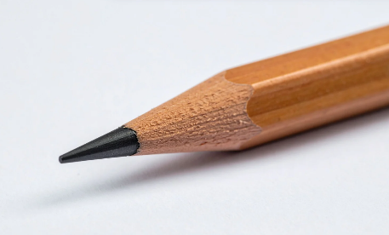
Lead-free pencils
Pencil cores are often called lead, even though pencil’s have never contained lead. The core is, in fact, made of graphite powder (a form of carbon) mixed with a binding agent. Why do we persist in calling the core "pencil lead?"
In the 1500’s, a large deposit of solid graphite was discovered in England. Metallurgists at first thought it a form of black lead, and the name stuck.
Soon people realized that the graphite was good for marking things and this newly discovered substance became extremely valuable. Guards were posted at the mine and once a sufficient supply of graphite was mined, the mine would be flooded until more graphite was needed.
Unfortunately, sticks of pure graphite are brittle, so people started embedding the graphite in things such as the hollowed-out pieces of wood. Thus, the pencil was born.

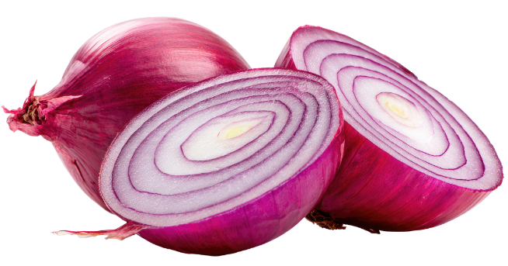
Fun things to do with onions
1. Remove rust and tarnish from utensils. Either shove the utensil (as in a knife) through the onion, rub the juice on with a cloth, or boil an onion in water for a couple of hours, then use the liquid to dip and polish metal.
2. Eliminate odors. It may seem counter-intuitive to use an onion to eliminate odors, but onions absorb odors quickly, including paint, fish, and burnt food. Cut an onion in half and leave it in the middle of the room.
3. Stop pets from "going" in the same spot. By placing an onion slice in the location where your pet has had an accident, you prevent it from repeating the mistake.
4. Soothe a bee sting. Cut an onion and rub it directly onto the bee sting. Let it remain for a few minutes, and the sting will diminish quickly.
5. Eat them! Studies suggest onions may lower high blood pressure, reduce heart attack risk, and even help protect against cancer--probably due to the presence of phytochemicals and the flavonoid, quercetin.
One large raw onion has only 63 calories, is made up of more than a cup of water and provides up to 20% of your RDA of vitamin C. Onions are also a source of fiber, vitamin B-6, folate, and calcium.

