Extra Articles Instructions
Below are three extra articles. To use one of these extra articles in your newsletter:
PRINT-FORMAT NEWSLETTERS
- Copy the text of an article below. Then paste it into an existing frame on your newsletter (highlight the existing text, then paste over it). You may need to edit the content to fit the space after pasting it.
- Copy the image separately, then paste it into your newsletter and move it into place using your mouse. You may need to edit the margins of your text to fit around your image.
EMAIL-FORMAT NEWSLETTERS
To use an article in the Mailchimp newsletter, copy and paste the text into your email newsletter (using a Text Block) and reformat as needed. Save the image to your own computer and upload it to your Mailchimp account.

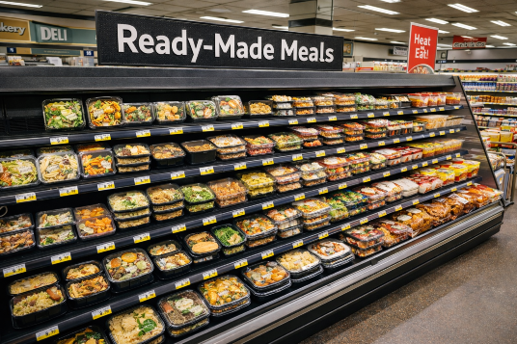
Grocery Stores Are Becoming Restaurants
Have you noticed how much prepared food there is these days in your local supermarket? It's not your imagination. Prepared food sections keep expanding while grocery aisles shrink. Rotisserie chickens, sushi counters, taco bars, heat-and-eat dinners. Stores are responding to busy households willing to pay more for a finished meal that's a cut above fast food and cheaper.

People Are Googling “How to Focus”

Not productivity hacks. Not hustle culture. Just focus. Searches for concentration, attention span, and mental fatigue are climbing. After years of scrolling and instant notifications, many people are realizing distraction has a cost. The reported incidence of ADD has climbed significantly in recent years, and whether people have ADD, they're clearly experiencing the effects of fractured attention. Focus is becoming a skill we need to practice.

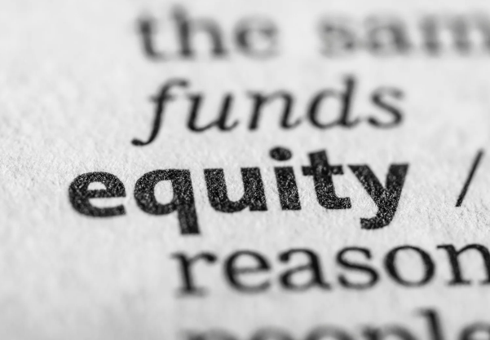
Using Your Home to Fund Your Future
Your home isn’t just a place to live — it’s one of the most powerful tools you have for reaching your financial and personal goals. As homeowners build equity over time, that value becomes a resource you can use strategically rather than just watch sit on the sidelines.
What is equity? It’s the difference between what your home is worth and how much you still owe on your mortgage. It’s actual, usable cash value and one of the key reasons we buy homes. Here are a few smart ways your equity can help you now:
- Make a move that fits your needs. If your current home isn’t quite right (too small, too big, or just not where you want to be) you can use built-up equity as downpayment money toward the next one.
- Invest in your current home. Equity can fund upgrades that improve lifestyle and boost resale value.
- Fuel personal goals. For some homeowners, equity can be a launchpad for things like education, a business venture, or even retirement planning (used responsibly, with the idea that there should be a strong pay-off).
- Provide a safety cushion. In tough times, knowing that you have equity and knowing the options available for tapping and using that equity can bring peace of mind.
If you’re curious how much equity you’ve built up and how to tap it, let’s connect to review the numbers and explore the options. Contact me for a consultation. ${First Name}, ${Phone}

