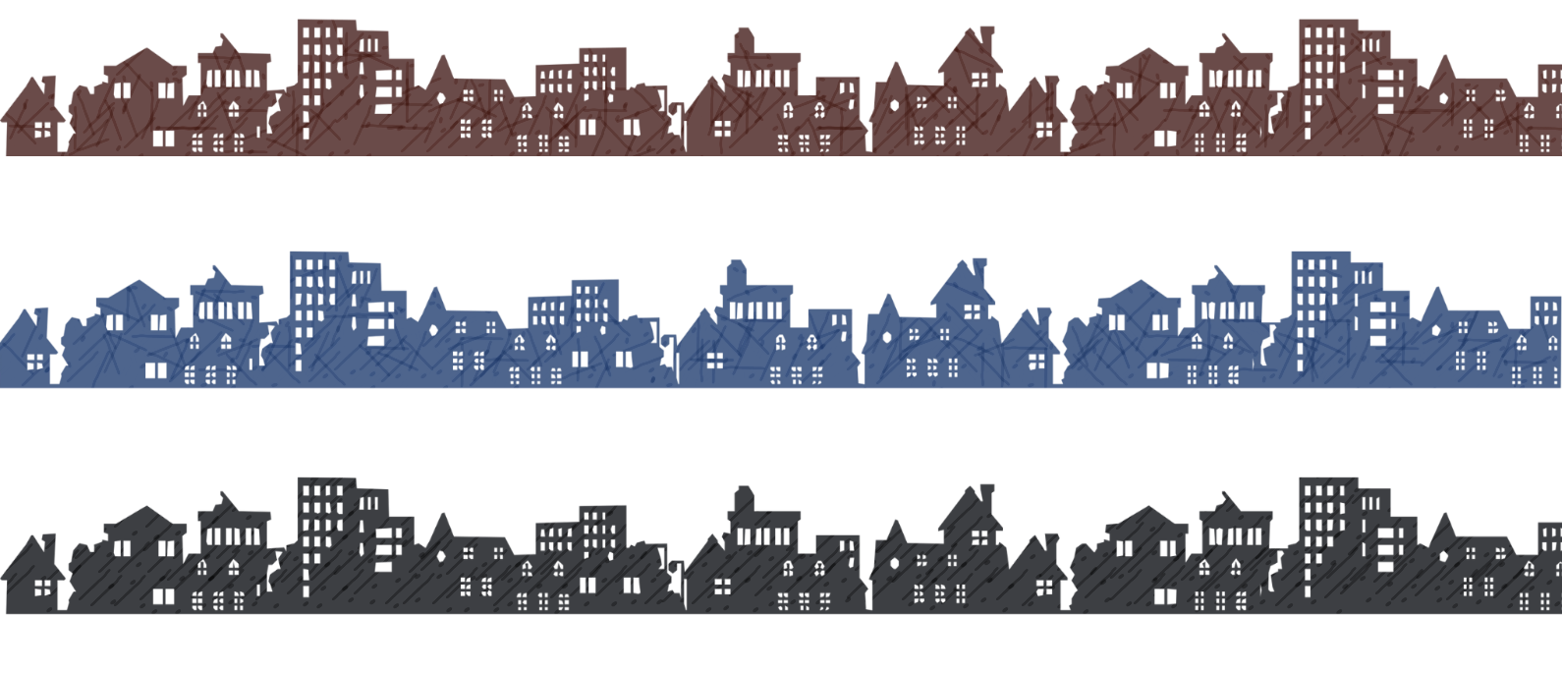

FRONT PORCH NEWS


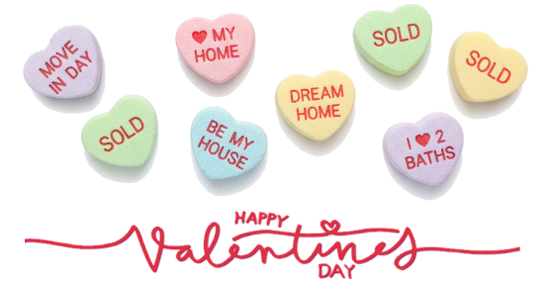


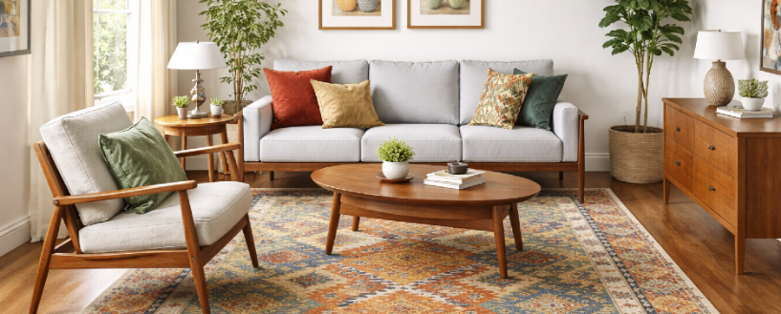
Your Name | 555-333-2222 | email@emailaddress.com | Your Website

Plan Your Love for An Entire Year
A husband went viral recently for sharing something unexpectedly romantic: instead of winging Valentine’s Day, he and his wife planned their entire year together in one sitting. All the vacations and anniversaries, all the quiet dinners, lazy Sundays, and those “we should really do that sometime” ideas.
Social media fell in love with the idea. It was two people saying, 'You matter enough to schedule time.' So, this Valentine’s Day, buy the card, but also spend a cozy day of planning dates. Then protect them like they matter. Because they do.

FEBRUARY QUIZ
You are trying to get out of a room alive. There are 3 exit doors. Behind door one is a lake of boiling lava. Behind the second are zombies who eat brains. Behind the third are huge lions who have not eaten for a year. Which door do you take?

Happy Valentine’s Day!
Do you need to get your sweetheart something special for Valentine’s Day? Let’s go find your dream home!

555-333-2222

What To Do When Your House Didn’t Sell
The reason homes don't sell is that they were mismatched to the market in some way. Read this to learn what you can do next. Or text me for a copy.

How to Make a Room Feel Bigger with Illusion
Have you ever walked into a home and thought, 'This feels huge,' only to realize the square footage isn’t that impressive? You’re not imagining things. Or maybe you are.
Optical Illusion — Psychologists have long studied a quirk of the brain called the Müller-Lyer illusion, where shapes can trick us into misjudging size. In the image here, the three lines are the same length. But the arrows at the
ends fool our brains into making a snap judgment. Even animals have been shown to be fooled by this trick.
In real estate, certain design choices naturally “stretch” our perception in similar ways, nudging the brain to read a room as larger than it really is.
● Using furniture with legs can show more of the floor, creating a feeling of expansive space. ● Using mirrors across from a natural light source can make a room feel larger, while taller mirrors draw the eye upward.
● Changing the direction of a table or floor rug can trick the eye into seeing a longer space. ● Strategically placed lighting can create an airy feel. ● Sometimes angling the furniture can make a space feel larger.
To Keep in Mind — For buyers, this is a useful reminder to trust the listed square footage, not just the feeling. For sellers, you don’t always need more square footage to create impact.


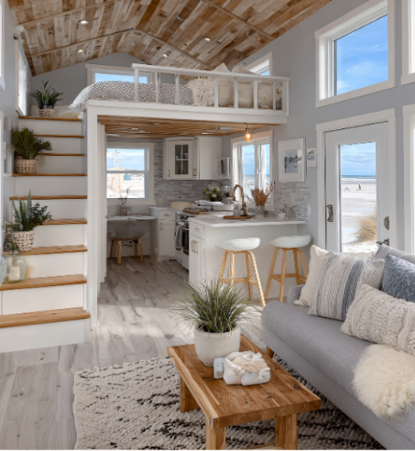


Slide this Alternative Article Over…
If you don’t need the mailing label area on this panel, you can slide this extra article over to cover the center. You can also delete the text inside the box and type your own article here.
To slide the article, click the edge of the article box. Then hold your mouse button down as you move it.
Delete any box (including this yellow box) by clicking on the edge of the box, then clicking delete on your keyboard.

More Homes Being Built for One
Not families. Not roommates. One person. Developers are increasingly putting up tiny homes, small condos, and compact rentals designed for solo living. Partly it's commerce, as they can put more units into a smaller footprint.
Partly it's responding to lifestyle changes, like later marriages and people choosing not to have children—which is ironic, since the downsizing of families is partially due to the unaffordability of houses. It’s a new way to look at starter homes and still offers a leg up on the property market as a steppingstone to something larger, if that’s the goal.

Your Winter Games Schedule!
The 2026 Olympics run February 6–22 in Italy, with 116 events set against Europe’s most spectacular alpine backdrops. The Opening Ceremony kicks off on February 6. The games will be split between two cities: Milan for ice events like hockey & skating, and Cortina d’Ampezzo for skiing & bobsled in the heart of the Dolomites. Use this schedule to plan your viewing parties! olympics.com/en/
milano-cortina-2026/schedule/overview

The lifetime value of investing in real estate
The three pillars of a stable future plan are strong investments, a paid-off home, and good health.
I can’t advise you on your workout routine or how to fund your retirement accounts, but I can help with the real estate side. My mantra is simple: get into the market as soon as possible, using a strategy that fits your stage of life. That might mean buying your forever home now, so it’s paid off in 30 years, or investing in practical “buy and hold” properties that grow in value and offer tax benefits.
Condos can be a great entry point—lower price, smaller down payment, and easier maintenance. Rents often cover the mortgage and condo fees and owning one or two could eventually provide the down payment for your ideal retirement home. I’m also a fan of multi-unit properties where, if you’re flexible, you can live in one unit and let tenants help pay down your mortgage. For some, house hacking makes sense too. And don’t overlook commercial properties; in some areas, they can be surprisingly affordable if leases cover the costs.
If you’d like help sorting through your options and creating a smart real estate plan, set up a consultation with me. We’ll review your priorities, talk through the numbers, and find the path that fits your goals.

To Insert Your Picture
- RIGHT CLICK on the placeholder image.
- From the floating menu, choose Change Picture.
- Find and insert your image from your computer.
- Resize and position your image using your mouse. (Use the Crop feature on the Shape Format menu to crop.)

See how to work with images inside text boxes in Word: https://www.youtube.com/watch?v=lKs8-1USlR4

WIN A $5 COFFEE CARD
Email me the answer to the question on page 1. ${Email}
- Last month's Q&A: An archeologist finds a coin inscribed with the date 50BC. She immediately knows it’s fake. How did she know? Back then, the concept of BC didn't exist.
Congrats to last
month’s winner!
${Contest Winner}
Your Name
Your Company
Address
Address
Real Estate License#

I’m so grateful!
Thanks to all of you who you have been part of my business world. A special shout-out this month to…
Thank you name 1
Thank you name 2
Thank you name 3

Your Name

555-333-2222

email@emailaddress.com

FRONT PORCH NEWS
This newsletter is for entertainment purposes only. Images are sourced from Canva.com. This information is solely for entertainment, and should not be substituted for medical, legal, financial or tax advice. This is not intended as a solicitation of listed property.

