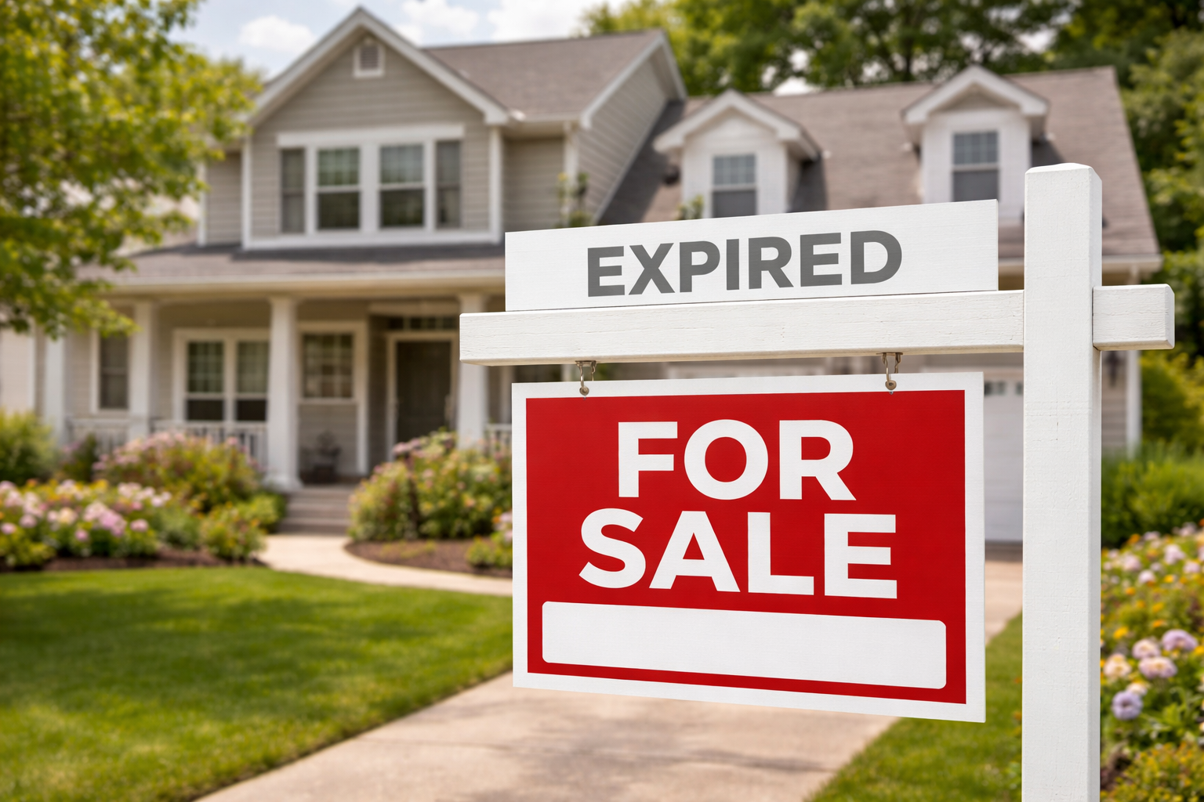

What to Do When Your House Didn’t Sell — and How I Can Help You Get It Right This Time
If your house didn’t sell the first time around, you’re not alone. And more importantly, you’re not stuck. Here’s what to do now.

An expired listing can feel personal. You cleaned, staged, hosted showings, rearranged your life around appointments—and still, no sale. That’s frustrating. It can also make people quietly wonder, Is something wrong with my house? Did I mess this up?
Here’s the truth: most homes that don’t sell aren’t bad homes. They’re simply homes that were mismatched to the market in some way—price, presentation, timing, or strategy.
And that’s exactly where I come in.
Relisting your home with me or listing for the first time with me is going to give us an advantage. Now that you’ve gone through a listing period, there’s data. We can use that data to plan better.

Let’s Do a Post-Mortem Together
Before simply listing again and hoping for the best, the smartest move is to pause and review what actually happened.
When I sit down with sellers after an unsold listing, I look at:
- How many showings you had
- What buyers and agents said in their feedback
- How your price compared to similar homes that sold
- How your photos and online listing performed
- Whether offers came in—and why they failed
This isn’t about second-guessing. It’s about replacing guesswork with clarity.
As your realtor, my job is to walk through this honestly and constructively. Sometimes the answers are simple. Sometimes they’re uncomfortable. But they’re always useful.

The Most Common Reasons Homes Don’t Sell
While every situation is unique, unsold listings usually fall into a few familiar categories.

1. The Price Didn’t Match the Market
This is the big one. Probably the biggest reason homes don’t sell. No one likes to hear it, but here’s what’s going on…
Buyers don’t compare your home to what it used to be worth. They compare it to what else they can buy right now. They just walked through 10 other houses in their price range. It’s about how your house compares to those 10 houses, not about how many upgrades you’ve done to the cabinetry or the quality of paint used. If those upgrades are not valuable to the buyers, they won’t pay extra for them.
Even being 3–5% above market value can dramatically reduce showings. And fewer showings almost always means fewer offers.
From the seller’s side, this can feel unfair. From the buyer’s side, it feels like an easy decision to move on.
When we revisit pricing, I rely on current area sales, buyer habits, and what your listing actually experienced. After a listing expires, we have something powerful: real data from the market itself.
That makes the pricing conversation more accurate.

2. The Home Didn’t Show Its Best
Today’s buyers decide whether to book a showing in about five seconds. Photos that are dark, cluttered, or dated can quietly sink a listing before anyone ever walks through the door. So can rooms that feel crowded or poorly lit.
When I review a listing for relaunch, I focus on:
- What to remove or simplify in photos
- Small visual upgrades that create space and light
- Furniture placement
- Lighting
- Fresh photography and descriptions
Often, the fixes are surprisingly modest. Professional photography can make a huge difference. Not to lie in photos by making the space look larger or brighter than it really is, but for the purpose of choosing the best angles and scenes.
You’d be surprised at how often photos do lie and that results in a negative buyer experience!

3. The Marketing Didn’t Go Far Enough
Putting a home on MLS is not enough. Buyers now are scrolling social media, watching short videos, browsing local listings on their phones, and relying on automated alerts. If a listing strategy is passive, a home can easily get lost.
When I relaunch a property, I look at:
- Photography and video
- How the home is positioned online
- Where it’s being promoted
- Whether it’s reaching the right buyers
- How quickly we can create new momentum
Momentum is often the key to selling a house. Active buyers will know if a house has gone “stale” and they’ll assume there’s a reason for that. They’ll want to see it, but already be thinking of low-balling the offer.
Sometimes the same home, presented differently, feels brand new to the market.

4. Negotiations Stalled
Sometimes a home almost sells. An offer comes in—but the timing doesn’t work. Or repairs crop up. Or financing conditions feel risky. And the deal collapses.
That doesn’t mean you should accept a bad deal. But it does mean there’s room to refine strategy. As your realtor, I help you decide:
- Where flexibility makes sense
- Where it doesn’t
- How to counter without pushing buyers away
- How to protect your bottom line and keep momentum
Negotiation is where experience matters most. We don’t want to push a real buyer away. We want to position your home as the right home for them close to your price.

Why Working With Me (Again) Is an Advantage
If I was your listing agent before, I already know:
- Your home
- Your timeline
- Your goals
- What feedback we received
- What worked
- What didn’t
That history is valuable. It means we’re not starting from zero—we’re starting with real market intelligence.
And if I wasn’t your previous agent, the same principle applies: I don’t just relist homes. I analyze them. Reposition them. Reintroduce them.
Selling works best as a collaboration. You bring the property.
I bring market data, buyer psychology, negotiation, and strategy.

A Smarter Plan Going Forward
When sellers succeed after an expired listing, it’s usually because we:
- Adjust price using real market data
- Improve presentation
- Refresh marketing
- Clarify priorities
- Work as a team
Selling a home isn’t a solo project.

One Last Thing
Not selling doesn’t mean your home is undesirable. It means the first plan didn’t fully connect with the market.
That happens, even with great homes, even in good areas, even with thoughtful preparation. Your price may have been too ambitious. Your home may have needed better preparation. Your marketing plan may need to be tweaked. Your buyer may have walked.
If your listing expired, or you’re thinking about trying again, let’s sit down and do a proper post-mortem. No pressure. Just an honest look at the data and a smarter plan for round two.
Sometimes the smallest adjustments make the biggest difference. And you don’t have to figure them out alone!

