Extra Articles Instructions
Below are three extra articles. To use one of these extra articles in your newsletter:
PRINT-FORMAT NEWSLETTERS
- Copy the text of an article below. Then paste it into an existing frame on your newsletter (highlight the existing text, then paste over it). You may need to edit the content to fit the space after pasting it.
- Copy the image separately, then paste it into your newsletter and move it into place using your mouse. You may need to edit the margins of your text to fit around your image.
EMAIL-FORMAT NEWSLETTERS
To use an article in the Mailchimp newsletter, copy and paste the text into your email newsletter (using a Text Block) and reformat as needed. Save the image to your own computer and upload it to your Mailchimp account.

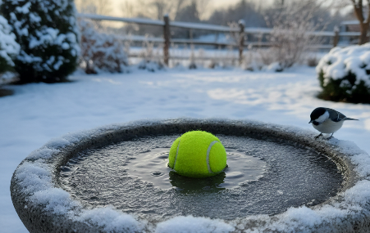
Why is there a tennis ball in the bird bath?
Here’s a clever cold-weather hack for critter lovers. Toss a tennis ball into your bird bath. As water cools, it freezes from the edges inward. The ball moves with wind and shifting water, preventing solid ice from forming and keeping a small opening usable, as long as the freeze isn't bad.

Log Into Your Dashboard
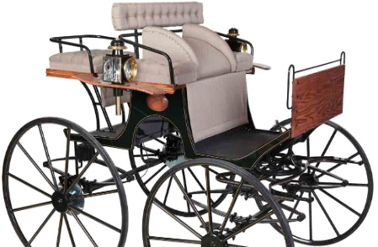
You might be interested to know that the term dashboard originally had nothing to do with a control center for a car or web page. It had no dials, buttons, or gauges. In fact, it was little more than a piece of wood. The meaning of dash being referred to, according to the Oxford Dictionary, is the “violent throwing and breaking of water or other liquids upon or against anything.” Think of an abstract artist dashing gobs of paint on a canvas. A dashboard was a wooden board placed at the front of a carriage to catch mud being dashed up by the horses’ hooves, keeping it from soaking the driver and passengers. As carts evolved into cars, the dashboard became a handy place to put instruments. But it kept its name.

Surprising Foods You Shouldn’t Eat Together
1. Black tea + milk. Black tea is rich in antioxidants that decrease inflammation, which is linked to heart disease and diabetes. Splashing even a little milk into your cup short-circuits the benefits because milk proteins bind to antioxidants in tea and prevent them from being absorbed.
2. Salad + non-fat dressing. When you avoid fat on your salad, you put up a roadblock to your absorption of nutrients. In fact, carotenoids linked to a reduced risk of cancer are more readily absorbed when paired with full-fat dressing as opposed to low-fat or fat-free varieties.
3. Burgers + beer. Both are processed by the liver, and your body naturally prioritizes breaking down the alcohol first, since it recognizes alcohol as a toxin. This leaves fat floating in your blood stream, where it can then be stored in fat tissue.

