Extra Articles Instructions
Below are three extra articles. To use one of these extra articles in your newsletter:
PRINT-FORMAT NEWSLETTERS
- Copy the text of an article below. Then paste it into an existing frame on your newsletter (highlight the existing text, then paste over it). You may need to edit the content to fit the space after pasting it.
- Copy the image separately, then paste it into your newsletter and move it into place using your mouse. You may need to edit the margins of your text to fit around your image.
EMAIL-FORMAT NEWSLETTERS
To use an article in the Mailchimp newsletter, copy and paste the text into your email newsletter (using a Text Block) and reformat as needed. Save the image to your own computer and upload it to your Mailchimp account.

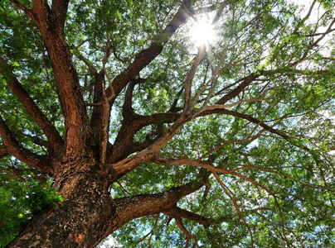
The Best Low-Water Shade Trees
If you'd like more shade without a bigger water bill, the right tree can do both. Many shade trees need regular watering, but some varieties thrive with surprisingly little once they're established.
Live oak is a favorite for its wide canopy and exceptional lifespan. Chinese pistache adds dense shade along with brilliant fall color. Honey locust creates light, filtered shade that's easy on lawns and garden beds. In warmer climates, desert willow offers colorful blooms while handling dry conditions with ease. California sycamore is another excellent choice for larger yards where there's room for it to spread.
Keep in mind that even drought-tolerant trees need consistent watering during their first year or two while developing a strong root system. After that, they'll usually need much less attention. Choosing the right tree today can mean decades of cooler summers, lower watering needs, and a yard that's both beautiful and easy to maintain.


Why Do We Like Picnics?
We have perfectly good houses and restaurants to eat in. Yet we often enjoy spreading our cloth on the ground and eating outside, alongside the bugs, wind, and sometimes heat. We know those things happen, yet we persist in wanting to have a picnic.
According to experts who study such things, eating outdoors engages more of your senses than eating at the kitchen table. Fresh air, birdsong, sunshine, and even the scent of grass all help create a richer experience, making meals feel more enjoyable.
Researchers have also found that spending time in nature can reduce stress and improve mood. Pair that with a favorite meal and good company, and it's no surprise that eating outdoors feels a little more memorable. Sometimes the best ingredient isn't on the plate—it's the setting around it.

Do Ceiling Fans Pay for Themselves?
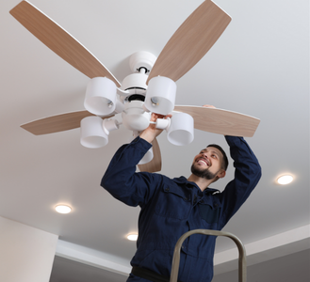
Ceiling fans are one of the most affordable home upgrades, and they can save money year after year. Most quality fans cost between $150 and $400 installed, depending on the style and whether new wiring is needed. Once they're in place, the savings can begin almost immediately.
A ceiling fan doesn't actually cool the room—it cools the people in it by creating a breeze. That wind-chill effect lets many homeowners raise the thermostat by three or four degrees during the summer without sacrificing comfort. Since air conditioning is one of the biggest energy users in most homes, even a small adjustment can reduce electric bills. Many fans also have a reverse switch for winter. Running them slowly in reverse helps push warm air back down from the ceiling.
If you use it year-round, a ceiling fan can often pay for itself in as little as a year or two through lower heating and cooling costs.

