Extra Articles Instructions
Below are three extra articles. To use one of these extra articles in your newsletter:
PRINT-FORMAT NEWSLETTERS
- Copy the text of an article below. Then paste it into an existing frame on your newsletter (highlight the existing text, then paste over it). You may need to edit the content to fit the space after pasting it.
- Copy the image separately, then paste it into your newsletter and move it into place using your mouse. You may need to edit the margins of your text to fit around your image.
EMAIL-FORMAT NEWSLETTERS
To use an article in the Mailchimp newsletter, copy and paste the text into your email newsletter (using a Text Block) and reformat as needed. Save the image to your own computer and upload it to your Mailchimp account.

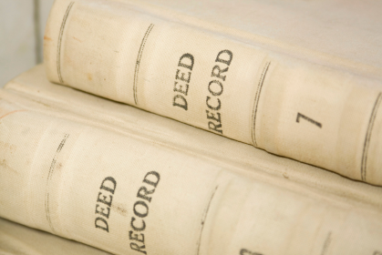
What’s Recorded (Officially) in Your Home’s History?
A variable that often derails real estate transactions is the discovery of previously unknown restrictions or easements.
For example, a house might have an old restriction that prevents anyone from adding on—something that sometimes happens in historic neighborhoods. Or a property might have a recorded easement that allows a neighbor to use a strip of land for access, even if no one has used that strip of land in the past 150 years.
Unfortunately, even if unused and unknown, these restrictions and easements run with the property, affecting and limiting the new buyer’s ownership rights. In some cases, these can be removed with a “quiet title” action. But in many cases, a property is stuck with them.
My job as your real estate agent is to help find solutions to these surprises and negotiate a fair settlement so you can still close successfully. No matter what comes up, I’ll make sure your interests are protected. Call me for experienced representation and guidance throughout the process.

The Nautical Origin of Rummage Sales
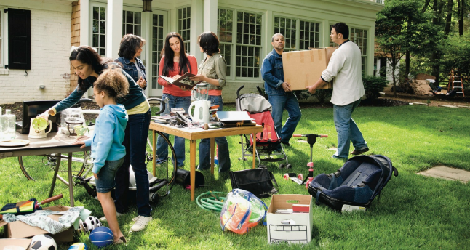
Whether you call it a garage sale, rummage sale, or yard sale, you are doing the same thing...selling your unwanted possessions for small change.
You may not know that yard and garage sales really got their start in shipyards in the early 1800’s with “rummage" or "rommage" sales, where shipping companies would sell unclaimed cargo at a discount.
The word rummage comes from the Middle French word arrumage, which meant the "arrangement of cargo in a shop's hold." The associated verb was arrumer "to stow goods in the hold of a ship." In the 1600's, the term came to mean "to closely search the hold of a ship, especially by moving things about."
Then in the 1800's ships began to hold popular "rummage/rommage" sales, though by now the cargo was unloaded from the hold before the sale. (The words rommage and rummage are phonetic differences, like po-tay-to/po-tah-to.) In the late 1800’s, rommage sales moved to community centers like churches. Then in the 1950's and 1960's, they became what we know them as today...rummage, yard, and garage sales.

DIY: 8 Refreshing Kitchen Updates You Can Do Today!
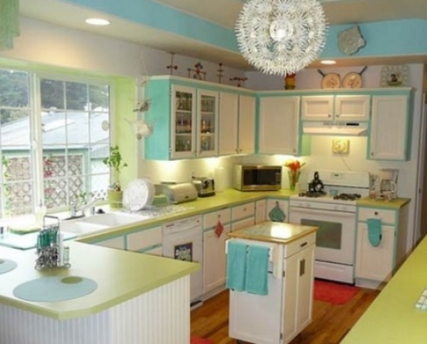
- Choose 3 complimentary colors and update everything you can to match, like paint, towels, rugs, small appliances, canisters, and curtains.
- Change your cabinet and drawer pulls. Buy a size that fits existing holes so you don't need to drill new holes.
- Add rope or stick-on lighting under or over your cabinets.
- Paint an unused wall/surface with chalkboard paint. Use colorful chalk to write a quote each day or week.
- Add a new backsplash using stick-on tile.
- Replace the faucet with something ultra-modern.
- Add some kitchen-relevant art, such as a café painting or kitschy spoon and fork mosaics.
- Replace boring lighting with something interesting or unusual.

