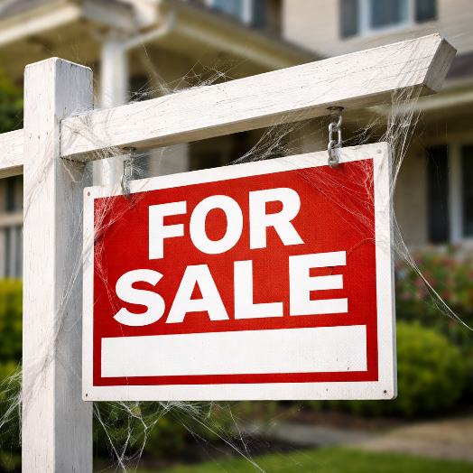

From COLD to SOLD: 9 Strategic Fixes for Stagnant Listings

From COLD to SOLD: 9 Strategic Fixes for Stagnant Listings
If your house is sitting unsold on the market, and you’re wondering how to breath new life into your listing, here are 9 strategic fixes.
When a listing stalls, it rarely happens by accident. Buyers are highly informed. They compare relentlessly. They move forward quickly when something feels right — and just as quickly move away when it doesn’t.
If your listing has gone quiet, the issue usually falls into one of three categories: Price. Presentation. Exposure.
Here’s how to evaluate each one more deeply.

1. Reevaluate the Pricing Strategy
When a property sits without serious offers, the market may be indicating that buyers do not perceive enough value at the current price.
That does not automatically mean a dramatic price cut is required. It means one of two things must change:
- Increase perceived value (improvements, staging, concessions), or
- Adjust the price to better align with competing options.
Buyers compare your home to similar listings in real time. If they can obtain more square footage, upgrades, or location advantages elsewhere for the same price, hesitation sets in.
It’s always better to price strategically from the start, but if the pricing is an unexpected issue, decide on the most acceptable path forward: Reduce the price or increase the value. The remainder of this article is about increasing value in one form or another.

2. Strengthen First Impressions Online
Your home’s first showing is on a screen. If a property generates few in-person showing requests, the issue may be its digital presentation. The photos matter! High quality imagery, along with a well-staged home, creates a desire to see it in person. Conversely, poor lighting, clutter, dated décor, or limited photography can reduce perceived value before a buyer ever steps inside.
Buyers decide within seconds whether to schedule a showing. Strong visuals increase perceived quality and create emotional engagement. Weak visuals do the opposite. They’re not just neutral. They actively discourage buyers.
In many cases, better photography and thoughtful preparation can materially change the response rate.

3. Refine the Property Description
A listing description should answer one key question: Why should we see this home?
Generic language fails because buyers are scanning dozens of properties at once. Specificity creates differentiation. Make sure your listings highlights functional advantages:
- Flexible space for remote work
- Energy-efficient upgrades
- Walkability or transit access
- Multi-generational layout options
When buyers understand the practical and lifestyle benefits, they are more likely to take the next step.

4. Eliminate Sensory and Maintenance Barriers
Buyers look for reassurance when they walk into a home. If they encounter lingering odors, visible wear, scuffed paint, or deferred maintenance, they experience subconscious concerns about hidden issues. Even small defects can reduce confidence. Do what you can to repair and refresh your home, from repainting to fixing small dings and dents.
It’s less about making your home perfect than it is about making it feel appropriate for the price you’re asking.

5. Increase Showing Accessibility
Limited showing windows reduce exposure. In a market where buyers often tour multiple homes in one day, inconvenience can lead to elimination. If a buyer cannot easily schedule a showing, they may simply move on. Flexibility increases opportunity. The broader the access, the greater the pool of potential offers.

6. Proactively Address Objections
Every property has one or two features that may cause hesitation, like a busy street, older mechanical systems, a smaller yard, a unique layout. If those concerns are not acknowledged, buyers fill in the blanks themselves — often negatively.
Your goal is to spin those things, not as positives (unless it makes sense to do so), but as transparent. Providing inspection reports, repair estimates, or transparent explanations builds credibility. It reframes uncertainty into clarity. People like knowing what they’re getting into.

7. Optimize Staging with Purpose
Staging is about demonstrating scale and function, not about decorating. Empty rooms tend to feel smaller because buyers struggle to judge proportion. Overcrowded rooms can feel restrictive.
Proper staging shows:
- How furniture fits
- How space flows
- How each room serves a purpose
The clearer the function, the easier it is for buyers to envision ownership.

8. Expand and Refresh Marketing Exposure
A strong launch matters — but ongoing exposure matters even more if the home didn’t sell right away. If a listing has plateaued, it may require renewed attention through:
- Updated marketing materials
- Targeted digital advertising
- Outreach to buyer agents
- Open houses
Sometimes the issue is not the property itself, but whether it has reached the right buyer. We need to come at it from a new direction or at least evaluate if a direction change is needed or one of the other issues can change the momentum.

9. Consider a Strategic Reset
Days on market (DOM) statistics influence buyer perception. If your home has been listed for longer than the average of similar homes, buyers will wonder why. That tends to draw out more bargain hunters or simply drop to the bottom of a buyer’s list of homes to see.
The fix is to, in some situations, temporarily withdraw the listing, implement improvements, and relaunch with adjusted pricing and new marketing to reset buyer perceptions.

The Bigger Picture
A stagnant listing is feedback that something’s off, from price to presentation to marketing. The sellers who succeed are those willing to interpret the signals and respond strategically.
If your property has cooled, the solution is rarely dramatic. It is usually strategic. With the right adjustments, COLD can become SOLD.
Let me know if you have questions about selling, or if your listing has expired and you would like to set a listing appointment.

