


Your Name | 555-333-2222 | email@emailaddress.com | Your Website



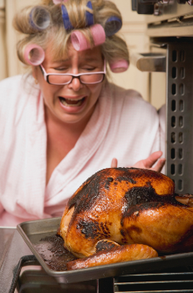



There really is a Turkey Hotline!
It's Thanksgiving morning. The guests are arriving in two
hours, the turkey is still frozen, and panic is setting in. Who do you call?
Butterball, of course! Since 1981, the company's Turkey Talk-Line has rescued holiday cooks from culinary disasters. It started with six experts answering about 11,000 questions. Today, more than 50 turkey specialists field over 100,000 questions during the holiday season.
You can call them at 1-800-BUTTERBALL. And if your turkey troubles happen at Christmas, the hotline is open through Christmas Eve! (But not Christmas Day.)

Thank you
Relationships are the key to a great real estate business and great service is key to returning customers and referrals. Thank you for being part of my journey as you have allowed me to be part of yours. I’m grateful.

~ Your Name

15 Downpayment Saving Ideas
Saving for a home can seem impossible until you break it into smaller, manageable steps. Want to get serious about saving for a home? Scan the code and read this report.

The everyday magic of gratitude
How often do you feel thankful for a hot shower? Or your refrigerator? Or your car for taking you wherever you please, whenever you like?
Probably not often. Unless, of course, something breaks. Funny how that works, isn't it? We're pretty good at appreciating the big things in life. But the everyday stuff? We barely notice it until something goes wrong.
And it's not just material things. Think about the friend who always answers when you call. The spouse who makes your coffee just the way you like it. The neighbor who waves when you drive by. Ordinary little pleasures that make life better.
Feeling thankful for little things isn't just a nice, quirky idea. It has real benefits for your mind and body, too. Scientists have found that practicing gratitude in little ways can measurably improve our mood and emotional well-being. Studies suggest it may help us sleep better and feel less anxious. And it can give us a more positive outlook that naturally draws people to us, opening the door to new friendships and opportunities. Not bad for something that doesn't cost a penny!
Start right now. Look around and find three things you appreciate. Nothing spectacular required. The warm room. The familiar voice. The beautiful fall morning. The color of your favorite chair.
Take a moment to really feel grateful for each one. No analyzing, no judging. Just appreciate it. Enjoy the moment. Enjoy every moment.



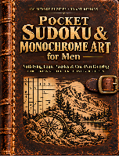
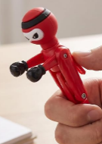


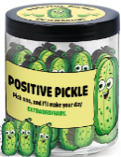
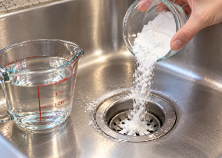
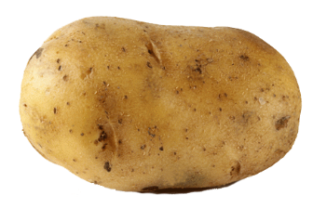

November Quiz Question
A farmer has seventeen turkeys. All but nine ran away. How many are left?

Gift Buying Season Has Begun! A Few Unique Ideas Under $15
All of these are available on Amazon. Just enter the bolded text into your search bar.

1. Christmas Mystery Box Word Search ($10.87). What fun! Solve the word search puzzles, then unscramble the leftover letters to reveal a surprise. Great Christmas gift for a puzzle lover.
2. DIY Terrarium Kit for Succulents & Air Plants - Terrarium Starter Kit ($14.94). Everything you need for a mini terrarium project. You provide the plant and glass container of your choice: mason jar, bowl, vase, etc.
3. Rechargeable Magnetic Work Light ($9.99). A pocket-sized flashlight that can attach to a metal surface. Handy for car repairs & power outages (stick it on your 'fridge). A practical stocking stuffer!
4. Cleverfy Shower Steamers ($9.99). Don't have time for a bath, but still want a relaxing aromatherapy experience? These will do the trick.

5. Pocket Sudoku & Monochrome Art for Men ($12.97). Medium sudoku puzzles plus mellow monochrome one-pen coloring pages, all with a rugged outdoor theme. Grab a Flair fine-point felt pen to go with it. A nice stocking stuffer for the man who has everything.
6. Ninja Knockout Action Pen Set by PATKAW ($14.99 for 4). For any adult who loves a good fidget toy. Instead of just clicking your pen over and over, you can battle with it. Another fun stocking stuffer!
7. FYC Socks for Women - Winter Wool Crew Socks ($9.99) Colorful, cute winter designs, perfect for low cut boots and shoes. A set of 5 for this price! Great stuffer idea.
8. DEARMINE 60 Positive Pickle Cards Jar ($9.99). Positive thinking cards to lift anyone’s spirits! A fun interactive gift anyone can share. A unique stocking stuffer.

That Smell Might be Your Kitchen Sink
Periodically, greasy food residue can build up in drains and the disposal, and the smell will let you know it's happened to you. To eliminate the odors here's a simple approach. First, flush the drain with a pot of hot water. Then pour in a half cup of baking soda. Then add a full cup of white vinegar. Let it fizz for fifteen minutes then flush again with a pot of hot
water.
Check
YouTube
videos
for more
advice.

Why Do We Call It a Spud?
This holiday season many of us will eat a ton of spuds: mashed, boiled, broiled, or baked. But how did the potato come to be called a spud? Its history is full of red herrings.
In one version, potatoes—which are a member of the deadly nightshade family—were blamed for syphilis, tuberculosis, and obesity. A group of Brits in the mid-1800’s wanted to eradicate the potato and called themselves the Society for the Prevention of an Unwholesome Diet. This spelled out the acronym SPUD.
Another version has to do with the name Murphy in Ireland, where potatoes are common. People named Murphy were often nicknamed Spud. Since the name Murphy (and hence, Spud) was as common as potatoes, the name transferred to potatoes.
The true history, however, is that spud came from a tool used to dig up potatoes. A 'spud' was a common name for a narrow-bladed shovel.
While you’re sitting around the table at holiday dinner, give your guests all three stories and see if they can guess which one is true.

Thank you, friends!
Thank you to all of you who you have been part of my business world. A special
shout-out this month to…
Thank you name 1
Thank you name 2
Thank you name 3

Quiz Contest-Win a FREE Coffee Card
Email me the answer to the question on page 2. Put the word QUIZ in the subject line. email@emailaddress.com
Last month's Q&A: Four people sit around a table. One stole a ring. Each accuses the other. ● Alice points to Ben. ● Ben points to Chloe. Chloe points to Dan. ● Dan points back to Ben. Two of them are lying and two are telling the truth. Who stole the ring? Ben.
Congratulations to last month’s winner!
November 2026 Your Name | 555-555-5555

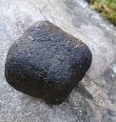

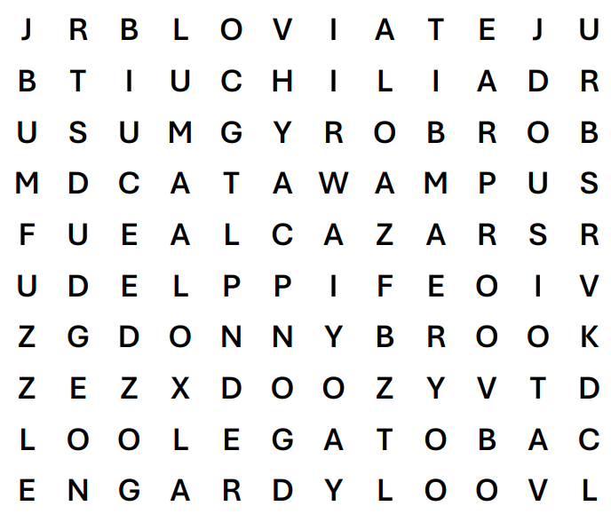

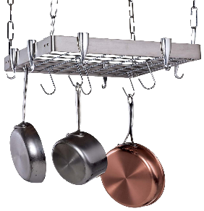


ALCAZAR
BLOVIATE
BORBORYGMUS
BUMFUZZLE
CABOTAGE
CATAWAMPUS
CHILIAD
DONNYBROOK
DOOZY
DUDGEON
FIPPLE
GARDYLOO

Weird English Words

Counter Intelligence
If you have a small kitchen, here are 5 ways to maximize space:
1. Use your oven for storage. You can store your baking dishes, cookie sheets, cooling
racks, and muffins tins in the oven. Remember to take them out before you turn the oven on!
2. Install hooks under cabinets for cups, strainers, oven mitts, etc.
3. Create your own pantry. If you don't have a pantry, you can put shelves in your garage, add an inexpensive cabinet to your dining area, or borrow space from the laundry area.
4. Add a roll-away counter. Use a butcher block counter on wheels. It can sit in the corner and store the extra kitchen appliances when you’re not using it.
5. Store pots and pans up high. Many of us have several feet of free space between the tops of our cabinets and the ceiling. Why not use it?

No Point in Holding Out for a Housing Crash
Those hoping for a housing crash face major disappointment. To match the ultra-low mortgage rates millions of current homeowners enjoy, home prices would have to plummet by 32%. According to a Barron’s analysis, the median home price would need to drop from $429,100 to $291,181 just to balance today's punishing rates.
That historic 32% plunge is even worse than the 27.5% crash of 2008, making a sudden affordability fix highly unlikely.

Nature Has a Square
Sense of Humor
Here's something you probably didn't need to know: Wombats
poop cubes. And scientists have spent years figuring out how, one even winning an "Ig Nobel Prize" for research. These Australian marsupials have unusual intestines that help shape their droppings into little blocks. Why cubes? Wombats use their droppings to mark territory, often depositing
them on rocks and logs. The
cube shape helps keep
everything from rolling away.
Now you know.


We’ve updated your template. Please right click on the image, then select CHANGE PICTURE from the floating menu.

Your Name
Your Company
Address
Address
Real Estate License#

High Income Isn't Always the Key to Getting a Mortgage
I’m sometimes asked how much money someone needs to earn to buy a house. Of course, it varies by the house price and interest rate, but in general, I think the belief is that there’s a threshold at which someone can be approved for a mortgage to buy. But that’s not always the case.
Someone earning $200,000 a year can be denied a mortgage because too much of that income is already committed to car payments, credit cards, and other debts. Meanwhile, someone earning $65,000 may qualify because they've consistently lived within their means, avoided overspending, and built substantial savings.
The difference isn't necessarily income. It's how they manage their money. Warren Buffett once observed, when talking about some of his wealthy friends, "I feel the possessions possess them, rather than the other way around."
Before applying for a mortgage, take a hard look at your debt. Reducing it can improve your chances of approval and potentially help you qualify for better loan terms. Better yet, you'll have less money
tied up in monthly payments, leaving more available to save, invest, or enjoy life without
financial strain.
Your Name
555-333-2222
email@emailaddress.com

This newsletter is for entertainment purposes only. Images are sourced from Canva.com. This information is solely for entertainment, and should not be substituted for medical, legal, financial or tax advice. Do not hold us responsible for actions you take without proper medical, financial, legal or tax advice. This is not intended as a solicitation of listed property.

Please share my newsletter with your friends & neighbors!

