Extra Articles Instructions
Below are three extra articles. To use one of these extra articles in your newsletter:
PRINT-FORMAT NEWSLETTERS
- Copy the text of an article below. Then paste it into an existing frame on your newsletter (highlight the existing text, then paste over it). You may need to edit the content to fit the space after pasting it.
- Copy the image separately, then paste it into your newsletter and move it into place using your mouse. You may need to edit the margins of your text to fit around your image.
EMAIL-FORMAT NEWSLETTERS
To use an article in the Mailchimp newsletter, copy and paste the text into your email newsletter (using a Text Block) and reformat as needed. Save the image to your own computer and upload it to your Mailchimp account.

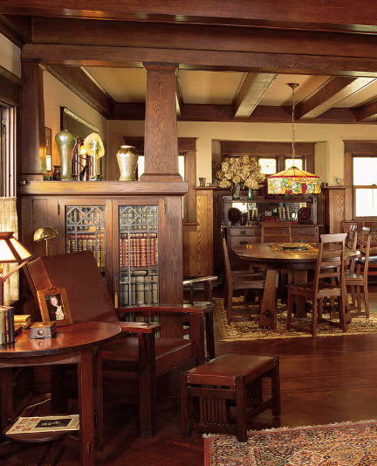

Where have all the built-ins gone?
Walk into a bungalow or Craftsman home from the 1910s or ’20s and you may find little features you rarely see in newer houses: a glass-front China cabinet built into the dining room, an ironing board that folds out of the kitchen wall, or a tiny hallway niche designed to hold the family telephone.
Built-ins were everywhere. Bathrooms had recessed medicine cabinets, breakfast nooks had built-in benches, and some homes had laundry chutes or even dumbwaiters.
Why build so much into the house? These features made efficient use of space and reflected everyday routines. A telephone stayed in one place. Ironing was a regular household chore. Dishes needed storage that didn't require another piece of furniture. Ready-made furniture existed, of course, but homeowners didn't have today's huge selection of inexpensive cabinets, organizers and space-saving products. Building storage and household conveniences right into the house was often a practical solution.
Many of these features disappeared as lifestyles changed and homes were remodeled. Today, though, built-ins are desirable again. Window seats, bookshelves, breakfast nooks and storage walls add character while using otherwise wasted space.

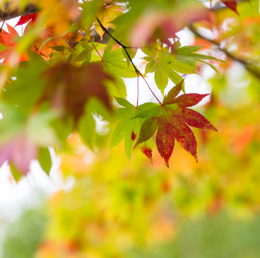
Why do leaves change color in the fall?
During spring and summer, leaves produce lots of chlorophyll, the green pigment that helps plants turn sunlight into energy. There's so much chlorophyll that it masks other pigments already present in the leaf.
As days grow shorter and temperatures cool, trees prepare for winter by slowing chlorophyll production. As the green fades, yellow and orange pigments called carotenoids become visible. Some trees also produce red and purple pigments called anthocyanins in the fall.
Weather can influence the show. Sunny days followed by cool—but not freezing—nights can encourage especially vivid reds. Drought, early frost and other conditions can make the season less spectacular. Eventually, the tree seals off each leaf from its branch. The leaf falls, helping the tree conserve water and energy until warmer, brighter days return in spring.

Here’s an easy Halloween craft to brighten any home
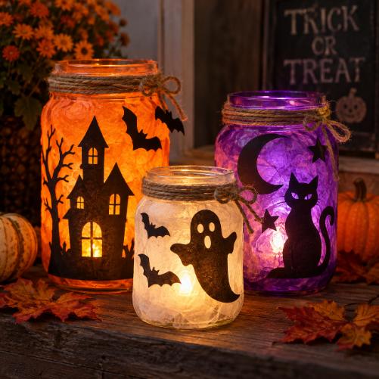
Save a few empty glass jars (or buy some mason jars) and turn them into Halloween lanterns for a porch, mantel, or party table.
Start with clean jars with the labels removed. Cut simple Halloween shapes—bats, ghosts, cats, pumpkins or crooked houses—from black construction paper and attach them to the outside of each jar. Then wrap or line the jar with orange, purple or white tissue paper to give the light a spooky glow. You can also use a little decoupage glue to attach torn pieces of tissue paper directly to the glass.
Finish with twine or ribbon around the rim and drop a battery-operated tea light inside. Make several in different sizes and group them together for a bigger effect.
This is an easy project to do with kids. Just let younger crafters handle the decorating while an adult does any detailed cutting.

