Extra Articles Instructions
Below are three extra articles. To use one of these extra articles in your newsletter:
PRINT-FORMAT NEWSLETTERS
- Copy the text of an article below. Then paste it into an existing frame on your newsletter (highlight the existing text, then paste over it). You may need to edit the content to fit the space after pasting it.
- Copy the image separately, then paste it into your newsletter and move it into place using your mouse. You may need to edit the margins of your text to fit around your image.
EMAIL-FORMAT NEWSLETTERS
To use an article in the Mailchimp newsletter, copy and paste the text into your email newsletter (using a Text Block) and reformat as needed. Save the image to your own computer and upload it to your Mailchimp account.


Let Cleaning Gel Do the Hard Grout Work
Nobody wants to clean grout, mostly because we associate it with kneeling on hard tile and scrubbing until our shoulders hurt. Most standard bathroom sprays are too thin; they simply run down the wall before they can break down soap scum or mold. For tile in your shower or floor, look for a thick, bleach-based cleaning gel (sometimes marketed as "toilet cleaning gel" with the angled nozzle). Apply it directly to the grout lines and let it sit for 15 to 20 minutes without letting it dry. When you rinse it off, you will find that the gel has dissolved the grime without you needing to apply any manual pressure with a brush.

Sharks may be older than Saturn’s rings!

It sounds like science fiction, but sharks are significantly older than trees—and may even be older than Saturn’s rings.
Shark ancestors appeared in Earth’s oceans more than 400 million years ago. Trees didn’t emerge until tens of millions of years later. And Saturn’s iconic rings may be relative newcomers, with some estimates putting their age at only a few hundred million years.
That means sharks were already swimming before the first forests appeared. They’ve since survived multiple mass extinctions—and may have been around long before Saturn got its famous rings.
Earth’s deep history is far stranger than it seems.

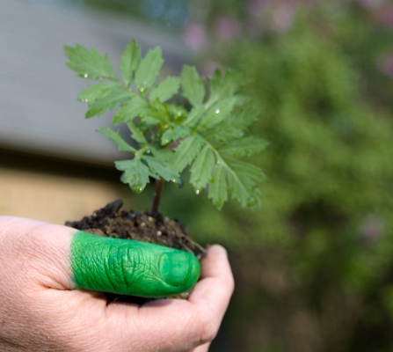
The Science Behind a "Green Thumb"
We often attribute thriving gardens to a natural "green thumb," but skill with plants isn't magic. It’s driven by continuous learning and micro-observation. Exceptional gardeners aren't born with secret genetic gifts; they actively seek out knowledge and pay closer attention to subtle physical cues.
Where a novice sees green leaves, a skilled gardener notices minor color shifts, drooping stems, or soil moisture changes long before severe damage occurs. Beyond observation, they are genuinely curious to understand how plants grow, taking the time to learn proper pruning techniques, soil chemistry, and specific light requirements rather than relying on guesswork. They also master microclimates, discovering how sun, wind, and frost uniquely affect different corners of their yard.
Crucially, successful gardeners treat failure as a valuable lesson. When a plant dies, they investigate why, adapt their approach, and apply that new knowledge next time. Ultimately, a green thumb isn't an innate gift. It’s the product of active learning, keen observation, and a genuine desire to understand nature.

