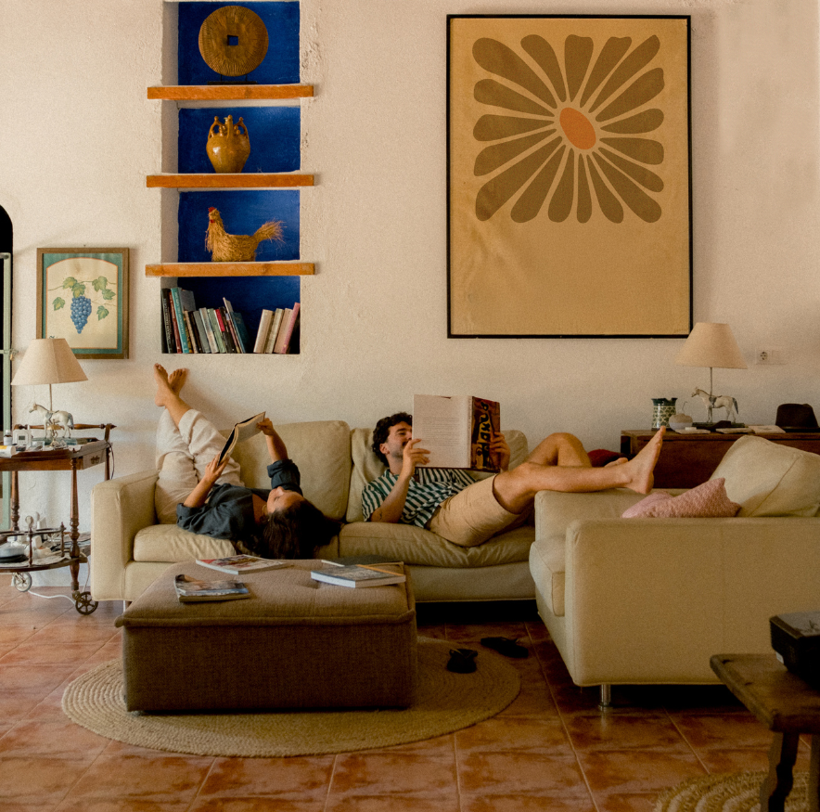

How to Decorate a Home (to your taste) When You’re Not a Decorator

IF THE WORD DECORATING MAKES YOU FEEL OVERWHELMED, YOU’RE NOT ALONE. MANY PEOPLE ASSUME GOOD-LOOKING HOMES COME FROM TALENT, TASTE, OR AN EXPENSIVE DESIGNER. IN REALITY, MOST WELL-DECORATED HOMES ARE THE RESULT OF A FEW SIMPLE DECISIONS MADE CONSISTENTLY.
.
You don’t need to know trends. You don’t need a perfect eye. You just need a handful of reliable strategies that remove guesswork and help you make confident choices.
Below are practical, low-pressure ways to bring color, harmony, and personality into your home—no decorating background required.

1. Choose Three Colors and Commit to Them
One of the biggest reasons rooms feel “off” is too many competing colors. An easy fix is to choose three colors and let them guide your decisions.
A simple formula:
- One main neutral (white, cream, beige, gray)
- One supporting color (blue, green, warm brown, soft black)
- One accent color (rust, mustard, blush, navy, forest green)
These don’t have to be bold. Soft, muted colors work beautifully. Once you’ve chosen them, repeat them throughout the room—pillows, throws, artwork, rugs, even books on a shelf.
This repetition creates harmony without effort. You’re not “decorating”; you’re just staying consistent.

2. Let One Statement Piece Do the Heavy Lifting
Instead of trying to make everything look special, pick one item per room to be the star.
This could be:
- A bold rug
- A large piece of art
- A dramatic light fixture
- A colorful sofa or chair
Once you have a statement piece, the rest of the room can stay simple. Neutral furniture, plain curtains, minimal accessories. The statement gives the room purpose and direction, and everything else just supports it.
This approach prevents overbuying—and overthinking.

3. Use Inspiration Rooms as a Shortcut
You don’t need to invent a look from scratch. Designers don’t. They collect references.
Find one inspiration room you genuinely like—not ten. It could be from:
- Pinterest
- A magazine
- A real estate listing
- A hotel or Airbnb you loved
Then ask:
- What colors are being used?
- Is the room calm or bold?
- Is it light and airy or cozy and dark?
- How much furniture is there?
You’re not copying the room—you’re borrowing its logic. Let it guide your color choices, furniture scale, and overall mood.

4. Match the Mood to How You Want the Room to Feel
A common mistake is decorating based on what looks “nice” instead of how you want the room to feel.
Before buying anything, ask:
- Do I want this room to feel calm, cozy, energetic, or elegant?
- Is this a place to relax, gather, work, or sleep?
For example:
- Calm rooms benefit from soft colors, fewer patterns, and natural textures.
- Energetic rooms can handle contrast, bolder colors, and graphic elements.
- Cozy rooms feel better with layers—throws, rugs, warm lighting.
When you decorate with mood in mind, your choices become easier and more coherent.

5. Repeat Materials, Not Just Colors
Harmony doesn’t come only from color—it comes from repetition.
Try repeating:
- Wood tones (light oak, walnut, black wood)
- Metals (all black, all brass, all chrome)
- Fabrics (linen, leather, velvet)
If your coffee table is wood, maybe your picture frames or shelves are too. If you choose black metal for light fixtures, repeat it in curtain rods or cabinet hardware.
This subtle consistency makes a room feel intentional—even if the items were bought at different times.

6. Use Fewer, Larger Accessories
Lots of small decor items can make a space feel cluttered and unfinished. A simpler approach is to use fewer items, but slightly larger ones.
Instead of:
- Five small frames → try one large piece of art
- Multiple tiny plants → one fuller plant
- Many knickknacks → one sculptural object
This creates visual calm and makes the room feel more grown-up without feeling formal.

7. Anchor the Room with a Rug
Rugs are one of the easiest ways to add color and pull a room together—but only if they’re the right size.
A common rule:
- Front legs of furniture should sit on the rug (or the rug should fully sit under key pieces)
A rug that’s too small makes everything feel disconnected. A properly sized rug anchors the space and often solves multiple problems at once—color, warmth, and cohesion.

8. Use Lighting to Create Warmth (Not Just Brightness)
Good lighting is less about how bright a room is and more about how it feels.
Simple upgrades:
- Use warm bulbs instead of cool white
- Add at least two light sources per room (lamp + overhead)
- Use lamps at different heights
Soft, layered lighting instantly makes a home feel more welcoming—even before decor is perfect.

9. Let Real Life Be Part of the Design
Homes that feel good are lived in. They don’t look staged.
Display:
- Books you actually read
- Art that means something to you
- Objects from trips or family history
These personal elements add warmth and authenticity that no store-bought decor can replicate.
If something makes you happy but doesn’t feel “decorator-approved,” that’s usually a sign it belongs.

10. Finish One Room Before Starting Another
One of the biggest confidence boosters is completion.
Instead of buying bits and pieces for every room, pick one space and finish it—even imperfectly. Adjust later if needed.
Seeing a finished room teaches you what works for you, builds momentum, and makes the rest of the house easier.

The Bottom Line
Decorating isn’t about talent—it’s about decisions. A few clear rules, repeated with confidence, go a long way.
You don’t need a perfect eye. You need:
- A limited color palette
- One strong focal point
- Consistent materials
- Rooms designed for how you actually live
Once you stop trying to decorate “correctly” and start decorating intentionally, your home will begin to feel like it belongs to you—and that’s the goal.

If you need a hand with this, You can also try online decorating services. or if you want to outsource i t all, i can refer you to some good decorators and stagers. just text or call me!

